

DEMONSTRATE KNOWLEDGE AND USE OF HAND OPERATED FIRE FIGHTING EQUIPMENT

SAQA UNIT STANDARD ID- 13961
NQF LEVEL 2/4 NQF CREDITS

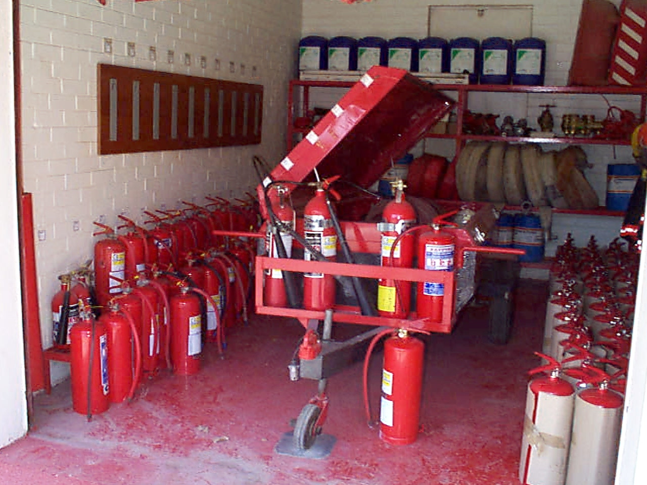

LEANER GUIDE CONTENT

A | Training Programme Introduction. | 03
1 | Procedure for dealing with fire at the work place. | 11
2 | Demonstrate knowledge of fire and repellents. | 21
3 | Identifying Different Types of Fires and Practice Fire  Prevention | 36
4 | Demonstrate the use of the various types of fire extinguishers | 49
5 | Demonstrate the use of fixed hose reels and ancillary extinguishing equipment. | 71
6 | Understanding different types of fire sprinkler systems | 85
7 | Explain how to evacuate the building. | 98

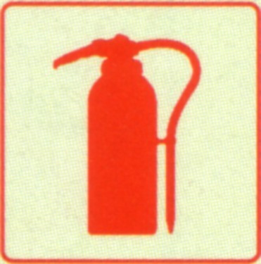
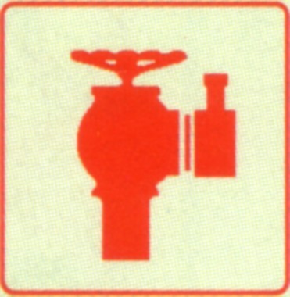



Training programme Introduction

Welcome to the training programme to Demonstrate Knowledge and use of Hand Operated Fire Fighting Equipment.

This training programme has been developed in accordance with the Skills Development Act (SDA) against a South African Qualification Authority (SAQA) registered unit standard.

The unit Standard title is” Demonstrate Knowledge and use of Hand Operated Fire Fighting Equipment and SAQA unit Standard ID number is 13961.

Learners assessed competent against this unit standard will be awarded the 4 National Qualification Framework (NQF) credits.

Who is the training programme for?

This training programme is designed for both novice and experienced learners who may be expected to perform basic fire fighting techniques while performing their daily duties should an emergency arise.

It is also make good business sense that employees who are expected to supervise these related activities should know what the correct procedures are so that they are competent to identify good, bad, safe or unsafe practices during the course of the supervision day/night shift.

Training Programme Purpose
Learners accredited with this unit standard will be able to select and use the appropriate fire fighting equipment to extinguish or control fires in the workplace.

Learners Role and Responsibilities
During the training, the learner is expected to:
- Take part in the activities.
- Ask questions.
- Enter into discussions that have meaning to the topic.

The training is meant to enable the learner to master the skills, and this can only be done by the learner making the effort to learn.
Learners will be expected to behave in a manner required in the work place such as the wearing of personal protective equipment where necessary.

Assessment of this Unit Standard

This programme has been aligned to registered Unit Standard. You will be assessed against the outcomes of the Unit Standards and will have to:

- Complete a knowledge assessment on the content of Unit Standard.
- Demonstrate that you are competent to carry out the practical components required by the Unit Standard, which you will be required to do after the knowledge assessment.
- Answer verbal questions related to the outcomes in the Unit Standard if required.
- You will also be assessed on your participation in-group work (e.g. case studies) during the programme, and the structured feedback, which may be required by some of the programmes.

REMEMBER WE
TRAIN TOWARDS THE UNIT STANDARD AND ASSESS AGAINST IT

How to use this Guide:

This workbook is your personal property. It is designed to serve as a guide for the duration of your training programme and as a handy resource.
It contains reading, activities, and application aids that will assist you in developing the knowledge and skills stipulated in the specific outcomes and assessment criteria.
Follow along in the guide as a facilitator takes you through the material, and feel free to make notes and diagrams that will help you to clarify or retain information.
Jot down things that work well or ideas that come from the group. Also, note any points you would like to explore further.
Participate actively in the skill practice activities, as they will give you an opportunity to gain insights from other person’s experiences and to practice the skills.
Remember to share your own experiences so that others can learn from you too.
Each module will be preceded by outcomes taken from the relevant Unit Standards.
These will describe what you must know and be able to do in order to successfully complete the programme.

MODULE ONE (1)

Procedure for dealing with Fires in the workplace

At the end of this module the learner will be able to:

- Understanding fire safety and awareness
- Explain what is meant by fire fighter
- Know the Qualities of a fire fighter
- Know the role and responsibilities related to be a fire fighter.
- Understand the dangers or emergency scene.
- Understand the procedure of attacking fire
- Know how to alert the emergency services

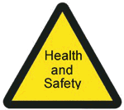

LEARNING OUTCOMES

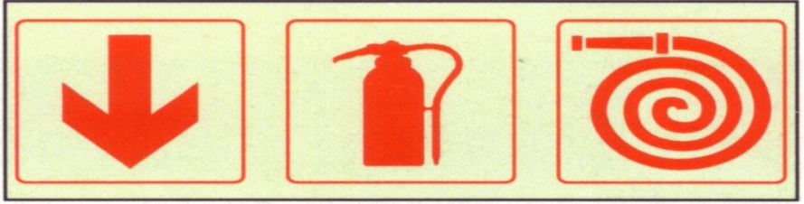

Introduction

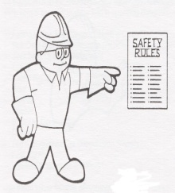
Fire has been one of man’s greatest allies through the ages, without it we would not have heat to cook food and many comforts. Even in modern society our lives will be very difficulty without fire.
We need it to generate electricity, to get rid of waste materials and for the production on many products. In fact without it, human will not be able to survive.

But the moment fire get out of control, it becomes human’s worst enemy.

In one year alone South Africa’s financial loss due to fire was R1.3 billion, while 417 lives were lost and countless injuries sustained. Over 52 000 emergency calls were made to fire Department countrywide.

The vast majority of these could have bee avoided if simple fire prevention measures
been in place or if swift, effective action been taken as soon as the fire was discovered.
Afire always has a negative consequence. It could be no more than the sheer inconvenience of clearing up the mess afterwards or of seeing many hours of hard work going up in smoke.
It is equally possible, on the other hand that a fire could result in serious injury, death and loss of property that could close down a business for good.
A major fire in an industrial facility always disrupts employment, which in turn impacts heavily on the community and the economy.
Noxious fumes releases during a fire can have a detrimental effect on the environment, particularly if hazardous materials are involved.
Fire can start anywhere and at any time either accidentally or deliberately.
Sadly, most are due to negligence of one sort or another.
By prudent assessment of the fire risks found in any given work environment as well as the development and implementation of good fire defence policy/procedure, the likelihood of a fire starting can be significantly reduced.

Aim

To promote awareness of the potential danger that fire present in the workplace.
To promote awareness regarding the part that management and staff can play in preventing fires from occurring as well as their role in helping to prevent the loss of life and property, reduce the chances of injury, and minimize the detrimental effects on the environment through efficient and effective response to a fire.

Fire Defence Policy

In the workplace it is the responsibility of management to develop and implement a fire emergency defence policy that fulfils both legal and insurance requirements and that is appropriate to the given work environment to ensure lives and property are safe.
It should be done in consultation with the local municipal fire department or other fire defence authority.
Once the anticipated risk of a potential emergency has been established and the level of emergency response has been determined, the written policy and organizational statement must be implemented.
It is everyone’s responsibility to maintain this safe environment and to take the appropriate action should an emergency arise.

For us to be able to familiar with the above aspects of fire defence policy,
we need to understand the following:

- General sources of fire ignition.

- Methods of extinguishing a fire.
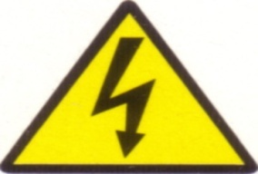
- Fire prevention strategy and

- Evacuation procedure.

Who is the fire fighter?

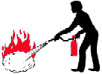

Any able person who has received recognised training by an accredited training provider on how to fight a fire.
In industry certain employees are selected and hold position as part of fire fighting team, these should also receive such training.

Fire Fighting means the extinguishing of fire to save lives and prevent damage to property/equipment.
This is achieved without putting yourself or others at risk.

As a fire fighter you will have to abide by the company rules, regulations and your employment conditions.

Qualities of the fire fighter

- Unselfish, alert, courageous and must exhibit initiative discipline and dedication,
NOTE:
A FIRE FIGHTER YOU MUST BE ABLE TO IDENTIFY AND SOLVE PROBLEMS.
A FIRE FIGHTER MUST BE A TEAM PLAYER

The Role and Responsibilities related to be a Fire Fighter
Once we are trained and certificated as a competent fire fighter, we have a duty to assist extinguishing fire in case of emergency and do the following under the instruction of Fire Marshall.

- Sound the fire alarm immediately after discovering a fire.
- Notify responsible person about fire.
- Inform people to evacuate the premises.

- Checking that the fire brigade has been summoned.
- Ensuring that the sprinkler control valve is open and remains open until the fire is under the control.
- A member of the team should be familiar with stream water and fuel pipes. It would be his duty in the event of a fire to shut off all flammable liquid and gas supplies in the vicinity of the fire.
- Try to contain a fire without putting their lives in danger until professional help arrives.
- Ensure that they are able to retreat to safety should the fire become uncontrollable.
- Rescue and help disabled people to leave the building safely.
- The team should, if possible include an electrician who conversant with electrical installations throughout the company.

The emergency Scene

The first Responder should protect him/herself from injury and death, since an injured or dead First Responder is useless to any emergency situation or victim/patient. In order to prevent mishap, the first responder must always remember to first observe the scene to determine if danger exist and additional help (i.e. fire department) is needed, before attempting to provide assistance.

First and foremost identity the presence of hazards. Then identify, if possible, the cause of the emergency and the immediate environment dangers.

Are you as a First Responder trained and able to handle the particular hazards that are found on the scene?
If not, the First Responder must call for the appropriate trained personnel to deal with the problem.

Remember the First Responder should never endanger him/herself.
The following are possible hazards that may encountered in the field:

- Fire or the potential of the fire.
- Hazardous materials- chemicals, gases, smoke and flammable liquids.
- Traffic
- Weather
- Hostile bystanders- riot and other similar situations.
- Electricity in a dangerous capacity- such as leakage.

NOTE:
A FIRE FIGHTER HAS A GREAT RESPONSIBILITY AND REQUIREDS A TRAINED, DEDICATION AND EXPERIENCED PERSON

Attacking fire procedure

Ensure that you are able to retreat to safety should the fire become uncontrollable. Do not allow the fire to block off your escape. Start attacking the fire from a distance, move in closer as the fire dies down. A crouching attitude should be adopted to protect yourself against heat and smoke.

When in the open, attack the fire from the windward side and move with the extinguisher to ensure that the agent reaches the whole fire area.
Always try to have another employee with an extinguisher backing up as a safe precaution and, where necessary, a two- prolonged attack should be made. Make sure that the fire has been completely extinguished.

How to alert Emergency Services

Alerting the emergency services or telephoning for the fire brigade during a crisis situation can turn out to be a very complex procedure, unless a pre- plan is made, as to how you go about reporting the necessary facts and information.

By making use of a systematic approach, the information can be reported in a” to the point” manner without wasting any time or causing any further confusion, which enviably is present during emergency situations.
As a first responder you must know your local fire department number and have clear marked on all notice boards at the work environment.

EMERGENCY TELEPHONE NUMBERS
National: ............................................................ 10177 (107)
Telkom: .............................................................. 1022
Cellphone: .......................................................... 112
ER24: ...................................................................084 124
Net care 911: .........................................................082 911
South African Police Services: ............................ 10111
Local Fire Brigade: ................................................
Other: ....................................................................

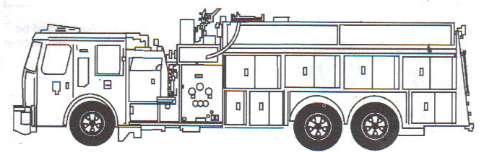

Alerting the Fire Department

The local Fire Department must always be notified of a fire no matter how small, one person should be nominated to make the call but everyone should know how.

When alerting the fire department, communicate clear. Provide all pertinent information about the emergency so that the fire department is able to respond quickly and efficiently and to arrange adequate manpower.
Fire departments operate emergency centres from which they dispatch the relevant emergency personnel.

Firemen are called out to attend to fires and they work from well equipped fire appliances.
Not all fire appliances are fitted out in the same way. Some have basic equipment to deal with grass fires, while others have very sophisticated equipment for dealing with emergencies such as building fires, depot fires and road accidents.

The decision as to which emergency vehicle to send as well as which equipment to arrange is based on the information relayed to the emergency room by the caller.

Systematic approach to alerting the fire department

- As soon as you are through to the fire department, state your name and the telephone number from where you are calling.
- Then supply the main reason for calling i.e. grass fire, house fire, car fire, factory fire.
- Supply exact address with useful land marks, nearest cross-road or name of suburbs.
- Report any complication, i.e. quote gate number in large factories, floor numbers in high rise building.
- Find out and record operator’s name and ask the operator to repeat the address, so you know that they knows where to send the brigade.

- Never replace the receiver of the telephone first, always wait for the operator to end off as this will ensure the rapid response and arrival of the fire brigade.
- Report back to the fire captain/Marshall

Module Formative Assessment:

(May be used for the Portfolio of Evidence)

- What is a fire fighter? (1)

1

- List the qualities of the fire fighter. (3)

1
2
3

- What is the Role and Responsibilities related to be a Fire Fighter? (5)

1
2
3
4
5

- Describe the possible hazards that may be encountered in the field of fire. (3)

1
2
3

- Explain how you will alert the emergency services? (5)

1
2
3
4
5

MODULE TWO (2)

Demonstrate knowledge of fire and repellents

LEARNING OUTCOMES

At the end of this module the learner will be able to:

- Know the definition of fire
- Explain, Understand the components (elements) of fire
- Know the different types of fuel
- Understand the characteristics of fuel
- Know the principles of fire fighting

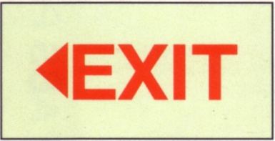

Introduction

It is essential for company personnel to know and understand the starting point of fire; this will gives the employees a better understanding on fire safety, fire extinguishing and prevention. In this module we will look at how certain elements can cause fire.

Definition of fire:

For our purpose it is sufficient to say fire is a chemical chain reaction known as combustion that occurs when fuel and oxygen (02) are brought together with enough heat to cause ignition.

The three components of a fire:

These elements are required to cause and sustain a fire, should any of the required elements be removed the triangle will collapse therefore combustion will cease.

Understanding the elements of fire

HEAT

A critical temperature must be reached for any fuel to vaporise and ignite. Once a fire has started, it will generally and maintains its own heat supply.
Heat is also called a source of ignition; Heat can come from many sources.
These are classified in five general categories:

Chemical
Electrical
Mechanical
Solar (sun)
Nuclear

Chemical heat:

Chemical heat is generated as the result of some type of chemical reaction. There are four types of chemical reaction that result in heat production:

- Combustion: This is heat generated by the oxidation reaction.
- Spontaneous heating: This is also as a result of the oxidation reaction but it is heat that is produced slowly by the oxidation of an organic material that is stored in such a way that insulation prevents the heat from escaping. Eventually it builds to the flash-point temperature and the material ignites without an external heat source. Discarded oil rags can also lead to spontaneous combustion.

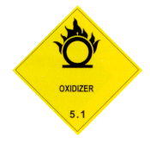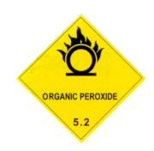

- Decomposition: the release of heat from decomposing compounds such as those found on a compost heap. Leads to spontaneous combustion.
- Heat from solution: Heat released as when certain chemicals are dissolved in water. Sulphuric acid added to wares is an example of this.

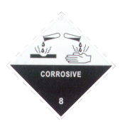

Electrical heat

Electrical heat energy can occur in a variety of ways:

- Resistance heating: When an electrical current is passed through a conductor such as a wire or appliance heat is generated. Resistance heating increases when the amount of current applied is more than the conductor or appliance is capable of handling such as happens with an overloaded extension cord or a tightly coiled cable.
- Dielectric heating: This type of heating is used in microwave ovens. A very-high- frequency voltage is placed across a non- conductive material. The molecules and/or atoms of the material vibrate and become hotter due to friction between the particles.
- Leakage current heating: When a wire is not insulated well enough to contact all the current passing through it, it will leak into the surrounding material causing it to heat up.
- Heat from arcing: a type of electrical heating that occurs when the current flow is interrupted. An open switch or a loose connection can arc and heat up.
- Static electricity: occurs when two surfaces, one charged positively and the other charged negatively come into contact with one another. The two charges are naturally attracted and seek to become evenly charged. When this happens an arc occurs. Lightning is static electricity on a very large scale.

Mechanical heat

Mechanical heat energy is generated in two ways:

- Heat of friction: When two surfaces move against each other it results in heat and/or sparks being generated.
- Heat of compression: When a gas is compressed heat is produced. Divers’ gas cylinders are warm to the tough after they are filled for this reason. Diesel engines ignite fuel vapour without a spark plug by the use of this principle.

Solar heat

- Solar heat is the energy transmitted from the sun in the form of electro- magnetic radiation. When it is concentrated on a particular point, as through the use of a lens, it will ignite a combustible material at that point.
Nuclear

- Nuclear heat energy is released when the nucleus of an atom is bombarded with energized particles in the form of heat, pressure and nuclear radiation.

OXYGEN (O2) 21%

Oxygen is life:

Just like people, animals and plants need oxygen to live, so a fire needs oxygen also to burn. Fuel can not ignite and burns without oxygen, even when heat is present.

Fuel-to-air- mixture:

The mixture of fuel and air has to be correct in order for a fire to start. If this is too much oxygen, the mixture will be too rich and when these are not enough oxygen, the mixture is too lean. In both cases the fuel won’t ignite.

Fire consumes oxygen

In the process of burning, a fire consumes oxygen; it is therefore possible for a fire to use up all its oxygen in a closed space. This fact can have serious consequences when fighting a fire.

However, certain materials, for example sodium nitrate and organic peroxide produce their own oxygen, even when burning in a space with no oxygen.

BEWARE:
A SMOULDERING FIRE CAN RE-IGNITE WHEN EXPOSED TO AIR (OXYGEN). DON’T OPEN DOORS AND WINDOWS UNTIL IS SAFE.
FIRE CONSUMES OXYGEN, OPENING DOORS AND WINDOWS
ON A SMOULDERING FIRE CAN CAUSE A BACKDRAFT EXPLOSION.

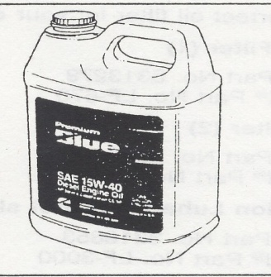

FUEL

- Fuel is any combustible (flammable) substance.
- Fuel is classified in three categories:
  - Solids- for example paper, wood, grass, coal, cloth, wax, leather, plastic, sugar, grain, cork rubber etc.

  - Liquids- petrol (gasoline), paraffin (kerosene), alcohol, diesel, paint, oil, varnish benzene, turpentine etc

  - Gases- Liquefied Petroleum Gas (LPG), butane, propane, hydrogen, natural gas, acetylene etc.

Even certain metals, for example sodium, magnesium, lithium, titanium, potassium, calcium and zinc can burn.

Solids, such as a block of wood, may be quite difficult to ignite, but reduce the block to shavings and the shavings will catch fire readily.
This has to do with the surface and mass (weight) of the fuel.
The smaller and lighter the fuel, the easier it is to ignite.
Important characteristics of fuel.

- Only gases or vapour burn.

No fuel burns in its solid or liquid state. Normally a solid fuel or liquids need heat to turn it in a vaporous state. It is these vapours that ignite. Therefore it is not the petrol in the tank that burns or explodes, but petrol vapours.

Flammable liquids have different flash-point, fire points and
Ignition temperatures

Definitions

- Flash point: minimum temperature where a liquid gives off enough vapours to form an ignitable mixture with air. When ignited it will flash, but not burn.

- Ignition point: minimum temperature at which any fuel will burn (ignite) instantly.

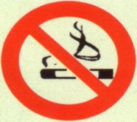
- Fire point: temperature at which flammable liquid produces enough vapours to maintain continuous burning.

Different flammable liquids gives off vapours at different temperatures, for example paraffin normally need to be heated to give off vapours, while petrol gives off vapour at extremely low temperatures.

Some liquid are more VOLATILE than others (gives off vapours or fumes at lower temperatures than other) of equal importance is the fact that liquid fuels can be vaporised without heating it to its FLASH –POINT.

Liquid fuel burn easily when vaporised. When handling liquid fuel it is important to remember that it is not the liquid that burns or explode, but the vapour- air- mixture.
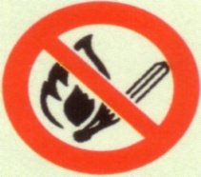
In general liquid fuels need much lower temperature to cause vaporization than solids.

“BEWARE”

Liquid fuels are a far greater hazard than solid- not taking away the danger, solids can constitute when handled incorrectly. The contents of aerosol cans are extremely dangerous when pieced or thrown into a fire.
Vessels containing flammable liquids (e.g. petrol tank, LPG cylinders) can rupture and explode when exposed to extreme heat. This type of explosion is called BLEVE (Boiling,Liquid, Expanding, Vapour and Explosion)

The Principles of Fire Fighting

Fire extinction, in principle, consists in the limitation of one or more of these factors, and the methods of extinguishing fire may therefore be classified conveniently under the following headings:
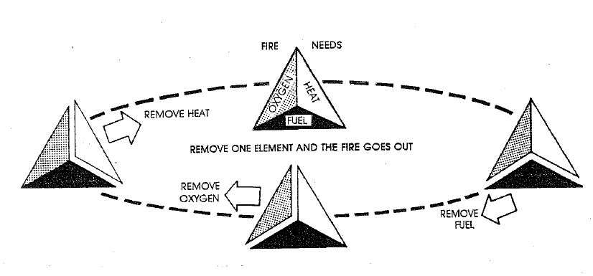
- STARVATION or the limitation of fuel.
- SMOTHERING or the limitation of oxygen.
- COOLING or the limitation of temperature/ heat.

In practice, specific methods of fire extinction often embody more than one of these principles, but it will be convenient to consider them according to the main principle involved.

STARVATION

The extinction of fire by starvation is applied in three ways:

- Removing combustion materials from the neighbourhood on the fire. Examples of this are, the draining of fuel from burning oil tanks” the working out of cargo at a ship fire; the cutting of trenches in peat, heath and forest fires, the demolition of buildings to create a fire stop; counter- burning in forest fires.

- Removing the fire from the neighbourhood of combustible materials as for instance, pulling apart a burning haystack or thatched roof.

- Sub- dividing the burning material, when the smaller fires produced may be left to burn out or to be extinguished more easily by other means.
A typical example is the emulsification of the surface of burning oil, whilst the beating out of heat fire owes much of its effectiveness is this:

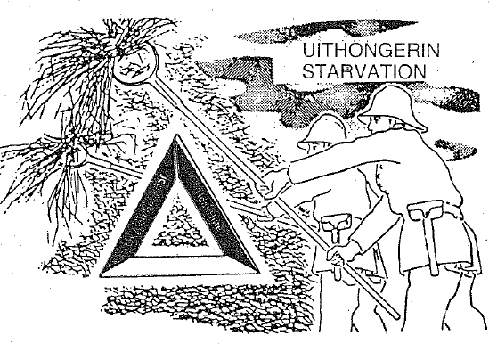

SMOTHERING

If the oxygen content of the atmosphere in the immediate neighbourhood of burning material can be sufficiently reduced, combustion will cease. The general procedure in methods of this type is to prevent or impede the access of fresh air to the sweat of the fire, and allow the combustion to reduce the oxygen content in the confined atmosphere until it extinguishers itself.

This principle is, of course, ineffective where, as in the case of celluloid, the burning material contains within itself, in a chemically combined form, the oxygen it requires for combustion.
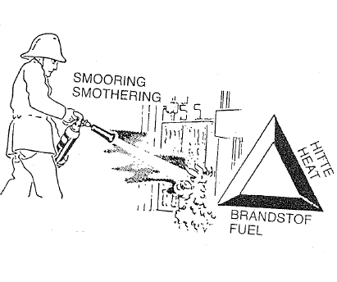
COOLING

If the rate at which heat is generated by combustion is less than the rate at which it is dissipated through various agencies, the combustion cannot persist. In applying this principle of fire extinction, the first step is to accelerate the speed with which heat is removed from the fire, thus reducing the temperature of the burning mass and as a consequence, the rate at which heat is removed from the fire, thus reducing the temperature of the burning mass and as a consequence, the rate at which heat is produced. In due course the rate at which heat is lost from the fire exceeds the rate of heat production and the fire dies away.

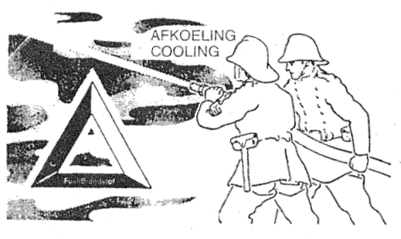

GROUP EXERCISE
The following exercise can be done once a specific section has been completed.
Discuss the following topics. Make your notes and elect a spokesperson to report back to the other groups.

(May be used for the Portfolio of Evidence)

- What is a fire? (1)
1.

- Name the three components of fire? (3)
1.
2.
3.

- Name the three categories of fuel. (3)
1.
2.
3.

- Give the three examples of each. (9)
1.
2.
3.

- Name the three categories of sources of ignition (heat). (3)
1.
2.
3.

- Describe the following terms. (3)
1. | Flash- Point:
2. | Fire- Point:
3. | Ignition Point:

MODULE THREE (3)

Identifying Different Types of Fires and Practice Fire
Prevention

LEARNING OUTCOMES

At the end of this module the learner will be able to:

- Identify the different classes of fires.
- Explain how the fire can spread
- Identify the general sources of fires.
- Explain how a fire may be prevented from starting.


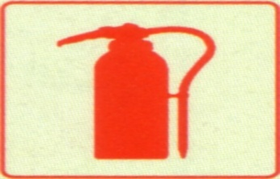

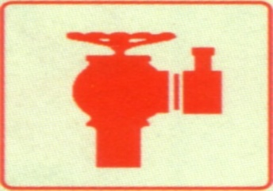

Introduction

Although all fire might look the same, some fires behave differently than others; the reason for this is that fires have different kinds of fuel.
Fire also has different causes or sources of ignition, this has a decisive effect on the way we fight a fire.

Recognising the different classes of fire is important because different types of fire are extinguished by different method. While one method of extinguishing can be perfect for one fire, it could be disastrous on another.
Before we can fight fires effectively let us first spent some time understand the classification of fires.

Fires are classified by its type of fuel and sources of ignition.
Classification of fires is as follows:

- Class A
- Class B
- Class C
- Class D
- Class E

Class A fires:

The symbol below is showing the classification of A fires

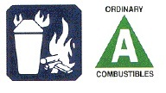

These are fires involving solids combustible material normally of an organic nature (compound), in which combustion generally occurs with the formation of glowing ember (paper, wood, coal etc). Class A fires are the most common, and usually extinguishing with water in the form of jet or spray (fog) (cooling).

Class B fires:

The symbol below is showing the classification of B fires

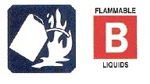

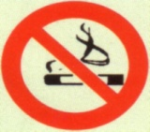
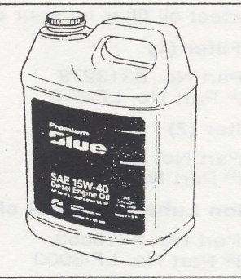
  - These are fire involving flammable liquids such as (gasoline, kerosene, turpentine, alcohol, oil, diesel, glue, paint ) for the purpose of choosing effective fire extinguishing agents, flammable liquids may be divided in to two groups:

      - Miscible with water.
      - Immiscible with water

In very simple terms, some liquids are more dense or heavier that water and other less or lighter.

The density of some liquids is equal to that of water when different liquids come in contact with water, those lighter or with a lower density than water will float on top of the water, while the density of the liquids and water is equal, the two will mix.

Most flammable liquids are lighter than water and will therefore float on top, however some for example alcohol and methylated spirits, will mix with water.

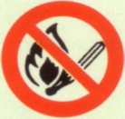
  - Depending on (a) and (b), the extinguishing agents includes water spray, foam, carbon dioxide (Co2) and dry chemical powder (DCP) will be used (cooling and smothering).

Class C fires:

The symbol below is showing the classification of C fires

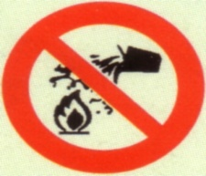
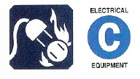

- These are the fires involving live electrical equipment.
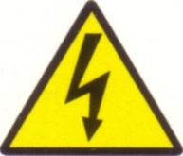
- Extinguishing agents containing water and foam are ineffective and even dangerous unless the electricity has been cut off or isolated from the energy source and use extinguishing method appropriate to what is burning.
- Extinguishing agents, which required and non-conduct of electricity and non- damaging to equipment is dry chemical powder and carbon dioxide fire extinguishers.

Class D fires:
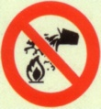
  - These are fires involving metals (sodium, magnesium, lithium, titanium, potassium, calcium and zinc can burn).
  - Extinguishing agents containing water, carbon dioxide foam, bicarbonate classes of dry chemical powder are extremely dangerous.

  - Powder graphite, powder talc, soda ash, lime stone dry sand and chalk are normally suitable for Class D fires.
  - Special fusing powders have been developed for fires involving some metals, especially the radioactive ones
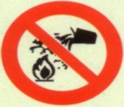
(Smothering)

EXERCISE
Discuss each class of fire and all the important aspects related to each type.

Class E fires:

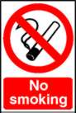
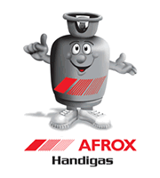

These are fires involving gases or liquefied gases in the form of a liquids spillage, or a liquid or gas leak, and these include methane, propane and butane. Foam or dry chemical powder can be used to control fires involving shallow liquid spills. (Water in the form of spray in generally used to cool the container to prevent BLEVE).

Boiling, Liquid, Expanding, Vapour and Explosion or simply extinguish by closing the gas cylinder (starvation).

Methods of fire spread:

Fire spreads very quickly and can soon be out of control.
The best example of how a fire may spread once after started is bush fire; and sometimes we may even find that as something burns, it break off, falls down and spreads the fire when it lands or touched other flammable items causes severe losses, pain, suffering and death.

Let us take closer look at the following methods of fire spread.

- Heat energy always passes from hotter to cooler regions by one of the following three methods:

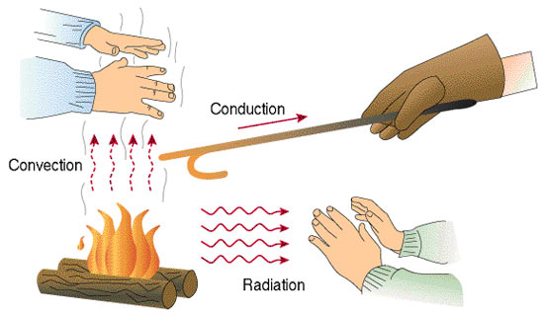

Convection

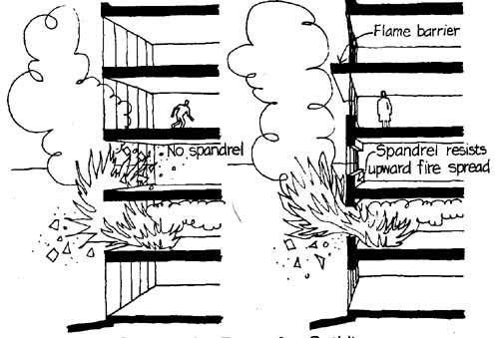

Convection is the upward travel of hot toxic gases, smoke and flame through an open stairwells, lift shaft, conveyors, overhead bridges between adjacent buildings, ducting for ventilation, fumes/dust extraction, open window or doors.
Convected heat is the primary agent of fire spread. When the upwards movement of a convection current is blocked, e.g. by a ceiling, the hot gases spread laterally along the underside of the ceiling (the mushroom effect) which may allow the fire to spread
either laterally or vertically.
Convected air currents can carry smoke and toxic gases long distances and can smoke log escape routes; they often carry burning brands, which can ignite combustible materials at some distance from the location of the fire.

Conduction

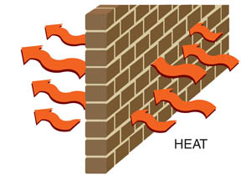

Conduction is the movement of heat energy through materials e.g. metals, floor and bricks.
Combustible materials stacked against or closer to the wall are in danger that they might be heated to their ignition temperature by conduction heat and ignite instantly.

Radiation

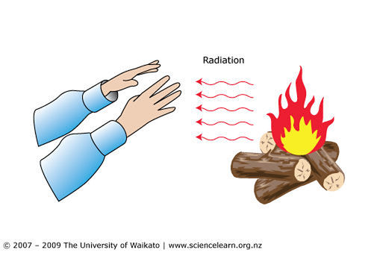

Radiation is the transfer of heat energy as electromagnetic waves from one place to another. Radiation does not heat gases it passes through but does heat solids and liquids it impinging on.

Radiant heat is transmitted to buildings not shielded from the fire.
Radiation passes through glass windows easily, and buildings with many or large windows are most likely to spread fire to their neighbours.

General Sources of Fire

To completely understand how we can prevent fires, we need to be able to identify possible sources or causes of fire

Let us take a closer look at some of these fire causes:

1 | Electricity | 25%
2 | Negligence (careless or deliberate acts of people) | 20%
3 | Liquefied Petroleum Gas (LPG) | 5%
4 | Spontaneous Combustion | 4%
5 | Chemical reaction | 1%

How Electricity can cause fire

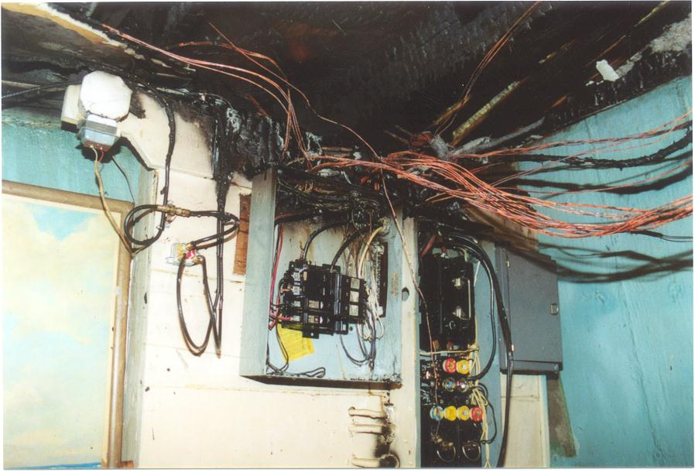

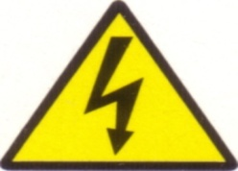
As can be seen from the above picture, electricity is the greatest cause of fire.
This symbol indicating warning of electric shock hazard.

Electrical fires may start because of:-

- Overloading of electrical circuits
- Damage electrical cords and leads.
- Leaving electrical appliances on.
- Failing to isolate electricity when overheating takes place or has been taken place.

- Defective electrical appliances.
- Loose electrical connections.
- Allowing light bulbs to come into contact with faulty shades.
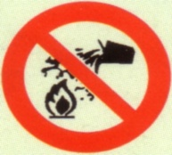
- Heated surfaces may cause a fire due to the grinding, friction, welding cutting, soldering irons etc.

- Heaters placed against or next to combustible materials.
- Removing plugs from sockets before switched off.
- Running electrical cords under carpets.

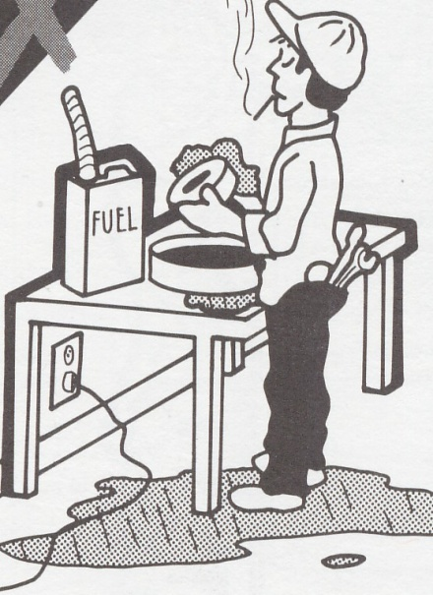
How Negligence causes fires:

- Smoke in bed.
- Children playing with matches and cigarette lighters.
- Pouring petrol, mentholated spirits or paraffin onto a fire as a starter.
- Placing lighted cigarettes where combustibles can be ignited by them.

- Keeping flammable liquids in class bottles which break easily and also keeping too much thereof.
- Allowing combustibles to accumulate.
- Heating polish on stoves.
- Spotting with benzene.
- Placing hot ash from fires into dirty bins.
- Arson.
- Throwing empty aerosol cans into a fire.

Fire caused by Liquefied Petroleum Gas (LPG):

In the workplace we often come across or handle
different types of gasses.
When working with or near gas we need to be
extremely aware of…
- Storing large quantities of gas.
- Gas cylinders left open or leaking.
- Gas cylinders left on or near heated surfaces.
- Faulty gas regulators.
- Smoking near.
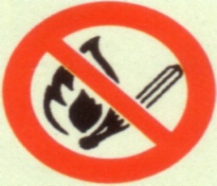
- Placing cylinder on the stove after power failure.
- Using appliances not designed for a particular cylinder.

Spontaneous Combustion:
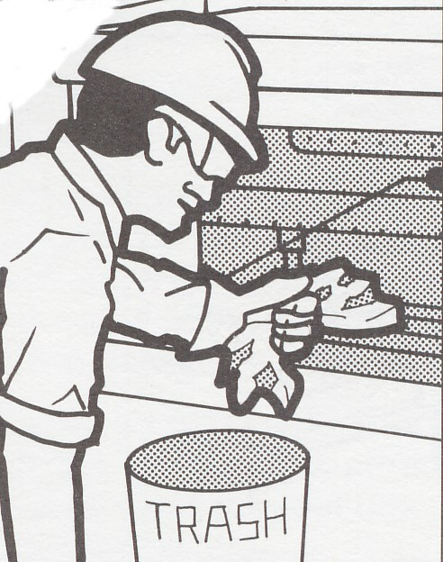
Certain materials, especially organic materials based on carbon, may react with oxygen at room temperature. Compounds such as linseed oil which contain carbon-carbon double bonds are very prone to this reaction.
If the fuel is a good thermal insulator, the heat generated in such a reaction cannot get away, the temperature rises which increases the rate of reaction and the situation escalates.
Eventually the ignition temperature is reached and true combustion commences. Alternatively the action of bacteria on certain organic materials can cause a rise in temperature eventually leading to the starting of fire.

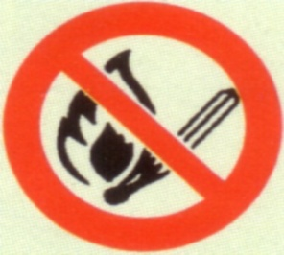
Fire caused by Spontaneous Combustion:
- Oil soaked rags
- Spilt oils saturating combustibles
- Leaving cans or tins of certain oil open
- Oxidizing agents left about.
- Compost heaps.
- Coal heaps
Fires caused by chemical reactions -

Chemicals are extremely dangerous when mixed or when they accidentally come into contact with other chemicals.
We need to be extremely aware of …
- Pool acid/chemicals like sodium hypochlorite
- Mixing of household chemicals detergents- e.g. toilet cleaners with washing powder.

- Split chemicals reacting .e.g. H202 (Hydrogen peroxide) with permanganate of potash and glycerine. Most of these chemicals are found in the home.
- Fertilizers coming into contact with petrol and other household chemicals.

Waste
Never underestimate the effect an old oily rag thrown into a waste bin, may react with other waste already in the bin and start a fire.

Preventing a Fire

Many fires start because of poor housekeeping procedures. Fire prevention starts with good habits to minimise the risk of an outbreak of fire.
Always take preventive measures and make sure that they become a habit.

Fire prevention starts with…

- Good housekeeping
- Proper chemical and flammable liquid control
- Maintaining all electrical appliances
- Controlling smoking rules
- Strict implementation of “Fire Procedures and Controls”
- Sufficient and properly checked fire fighting equipment
- Frequent surveys and risk assessments

REMENBER!
MATERIALS, LIQUIDS AND ITEMS WITH A HIGH FIRE RISK
MUST BE STORED AND KEPT APART

Good Housekeeping

Good housekeeping means that we place items in the correct designated areas, and ensure that items are stacked and stored correctly.

DEFINITION!
GOOD HOUSEKEEPING MEANS…
A PLACE FOR EVERYTHING AND EVERYTHING IN ITS PLACE
AT ALL TIME:

Fire Precautions
  - Procedure in event of fire
All employees should know the location of:
Fire extinguishing equipment.
Alarm call points.
Telephones from which the fire brigade can be called.
Escape routes and fire exits.
Assembly points.
  - Fire protection equipment
Any damage should be reported immediately to the fire safety officer.
Easy access should be left to extinguishers, hose reels and hydrants.
  - Means of escape and fire brigade access
Doorways and corridors should not be obstructed.
  - Smoking
Control of smoking and the provision of suitable bins for discarded smoking materials.
  - Heating
No portable or mobile space heaters should be used without the express permission of the fire safety officer.

  - Electrical equipment
Switch all electrical appliances off when not in use and isolated them from the main circuit.
Make sure that electrical points are not overloaded.

  - Gas Cylinders
Only the cylinder in use should be kept in the work place. Reserve and empty cylinders stored as directed by the fire safety officer.
  - Flammable liquids
Store all hazardous materials under lock and key in a safe compound, preferably away from the main building.
Make and identify flammable liquids clearly in the proper containers and store them in safe conditions.
Do not keep flammable chemicals any longer than necessary.
Highly flammable liquids (flash point below 32°C) require a hot- work permit.
  - Waste and rubbish
Dispose of waste materials, such as oil cotton waste, rags, etc in sealed container.
Maintenance of good housekeeping and care in disposal of waste materials which provide tinder for fire ignition.
  - Special precautions
Control of welding and cutting units, grinding tools and similar equipment which may cause sparks or heat. When work of this type is carried out away from established locations” permission to work” permits should be issued by the company/plant fire officer when he is satisfied that it is safe to do so.
There must be a continuous inspection program to ensure that the rules are being observed throughout the plant/ company.

EXERCISE: Discuss good and bad housekeeping aspects.

Summary of fire Behaviour

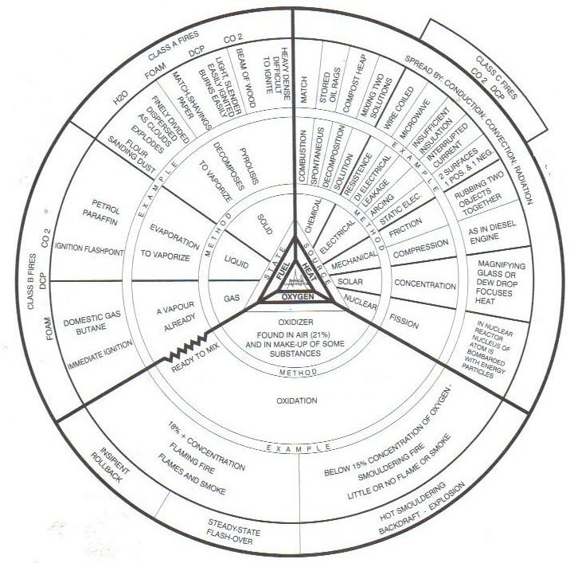

GROUP DISCUSSION

The following exercise can be done once a specific section has been completed.

Complete the following sentences by filling in the words below:

(Fuel, flammable liquids, ignition, metal, magnesium, electrical heat, petrol, oil wood, sodium, paper, propane. grass, water and foam, starvation, cut of the gas supply (close the valve) or keep the container cool, flammable gas, diesel, dry chemical powder, solids combustible materials, water and foam. Butane, methane)

- A fire can be cooled by using ----------------------------------------------------------
- A fire can be smothered with ----------------------------------------------------------
- The best way to extinguish a gas fire is to------------------------------------------------------------------------------------------------------------------------------------------
- The method is called --------------------------------------------------------------------
- ------------------------------------------------ Should not be used on Class C fires.
- Class A fires are fuelled by -------------------------------------------for example
---------------------, ---------------------------- and -------------------------------------
- Class B fires are fuelled by -------------------- For example ----------------------------------------------------------------- and -----------------------------------------------
- Class E fires are fuelled by -------------------- For example ------------------------------------------------------------------ and ------------------------------------------------
- Class C fires usually, start with an ------------------------------ source of ignition.
- Class D fires are fuelled by certain ------------------------------------ for example
----------------------------------------- and -----------------------------------------------
11) Fire are classified by its types of --------------------------------------------- and
Source of ----------------------------

NOTES:

------------------------------------------------------------------------------------------------------------------------------------------------------------------------------------------------------------------------------------------------------------------------------------------------------------------------------------------------------------------------------------------------------------------------------------------------------------------------------------------------------------------------------------------------------------------------------------------------------------------------------------------

MODULE FOUR (4)

Demonstrate the use of various types of fire extinguishers

LEARNING OUTCOMES:

At the end of this module the learner will be able to:

- Identify the different fire fighting equipment.
- Explain when to use which type of fire fighting equipment to which type of fires.
- Demonstrate how to use the different fire fighting equipment.
- Know the possible hazards when extinguishing fires.
- Describe general procedure for dealing with outdoor and vehicle fires.
- Know how to use the fire blanket.
- Understand checks, maintenance and service of fire equipment.

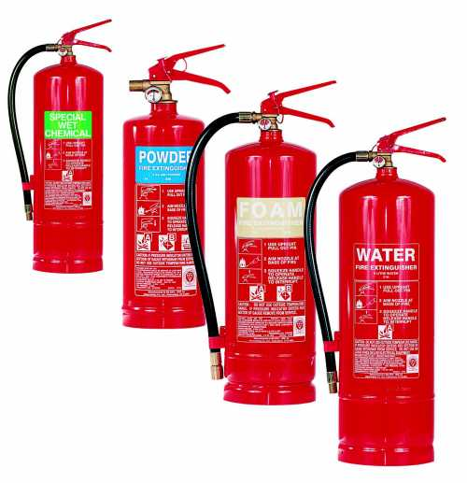

Introduction

Now that the different types of fire can be identified, we must get to know which way to extinguish it for this purpose.
Special equipment has been designed to assist fighting fires, is called a portable fire extinguisher.

Portable fire extinguishers are classified according to the types of fires for which they are intended to extinguish. It can be dangerous to attempt to extinguish a fire with the wrong fire extinguisher.

Before a fire extinguisher is selected for a specific location, the potential fire risk (the type of fire and the anticipated severity that is likely to be encountered there)
should be assessed. The extinguisher should then selected according to the nature of the expected application.

Fire fighting agents are usually expelled for portable extinguisher by one of two methods

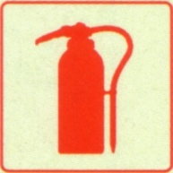
- The contents can be expelled from the extinguisher by means of a gas cartridge.
- This type of extinguisher is still in use in some places, but is not considered as modern technology any more.
- Most commonly used is the extinguisher where the fire-fighting agent is propelled by internal or stored pressure.

They are available in various sizes. The large the cylinder, the heavier it will be to handle. The weight should be kept low for easy handle but without compromising on the amount of extinguishing agent that may be required to deal with a potential fire.

Once again each situation will dictate the requirement.
If the environment contains large amounts of easily ignitable materials or substances then volume may be a very critical consideration.

Before we can fight fires effectively let us first spend some time understanding the installation and different types of fire fighting equipment.

We will also look at the correct fire fighting procedure

Fire Fighting Equipment

Depending on the work environment and the risk assessments conducted, the Safety and Fire Officers will have received expert advice on what type of fire fighting equipment to install at your workplace.

The installation of fire extinguishers should:

- Not be more than 23 metres apart
- Fire extinguishers should be conspicuously mounted near the exit of the area with the top of the carrying handle approximately 1, 5 meters above the ground level for easy removal.

- All fire fighting equipment must be easily accessible and numbers.
- Wherever where fire extinguisher, hose reels, fire alarm and fire hydrants are installed, description and location signs must be installed above the fire equipment to highlight their position.

- Where fire hydrants are provided with adjacent hose storage boxes, corresponding numbers must be clearly painted there on.
- Fire hose storage box must contain at least 2x 63mm fire hose and one fire branch.
- Demarcation on floor areas will not be required in offices flooring.
- Red and white demarcation lines will not be less than 50mm and not more than 75mm in width.
- Fire fighting equipment must be properly maintained and serviced annually.

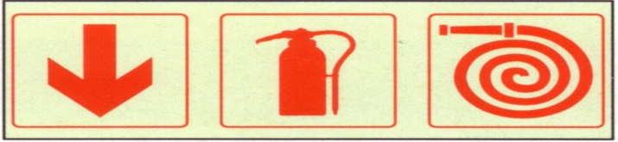

REMEMBER…
FIRE EXTINGUISHERS LOCATED IN CORROSIVE ATMOSPHERES
SHOULD BE INSPECTED MORE OFTEN AND SERVISED EVERY SIX MONTH

Different Types of Portable Fire Extinguishers

Dry Powder (Colour of label is blue)

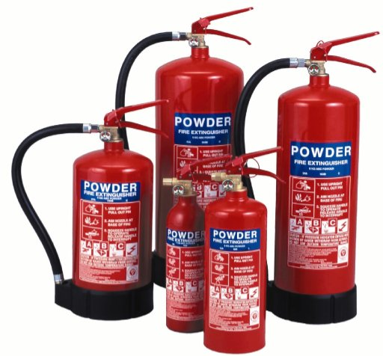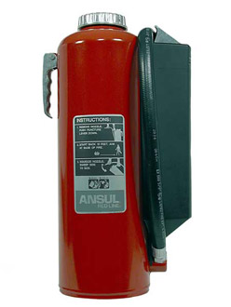

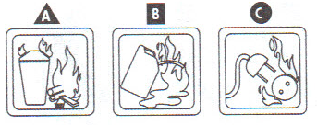

Extinguishing action: (Chemically inhabits combustion. It has a blanket effect on fire especially Class A, B and C fires.)

After checking the fire extinguisher, turn it upside down and shake it a couple times to loosen the powder.
Break the seal and pull out the safety pin.
Give a short burst of the agent to see if is functioning.
Aim the nozzle at the base of fire, Squeeze the trigger and move towards the fire up wind direction with a rapid sweep motion until the fire is extinguish.
Always put a cylinder down on its side when its contents are exhausted.

Advantages:

It is probably the most effective agent to extinguishing flammable liquids fires. It is also a non- conductor of electricity and be safely used on fires where there may be risk of electric shock.
Disadvantages:

Its cooling properties are limited and it gives no protection against re- ignition if the application ceases.
Causes wide spread white dust.
It is susceptible to wind and corrosive to metals.

Carbon Dioxide fire extinguisher (CO2) Black labels:

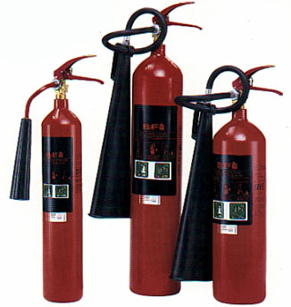

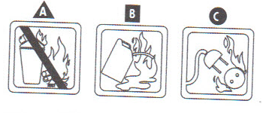
- Carbon Dioxide gas is expelled under great pressure in a powerful concentration.
- The wind factor must be taken into account when operating a CO2 portable fire extinguisher…PASS

P – PULL THE SAFTEY PIN
A – AIM AT THE BASE OF THE FIRE
S- SQUEEZE TO TEST
S – SQUEEZE AND SWEEP

- It is suitable for live electrical equipment and harmless to most delicate mechanisms and machinery. It is also non- toxic and clear to use.
- Carbon dioxide extinguishers are suitable for Class B and C fires, capable of smothering, quenching and cooling.
Advantages:
Carbon dioxide is non- conductive and harmless to the environment. It is useful for fires involving electrical appliances, computers and vehicle as little damage is done to them.
Disadvantages:

Inhaling large quantities of co2 can lead to asphyxiation.
Causes freeze burns if the skin comes into contact with the base or the nozzle.
After being used indoors and the fire has been extinguish, the room should be adequately ventilated before use.
Co2 has a little cooling action and the fire can re- ignite once the air comes into contact with it again.
The rapid change from liquid to gas at the diffuser (between the hose and the horn) generates static electricity that can shock the operation therefore only held by its insulated handle.

Water fire extinguishers (Red labels)
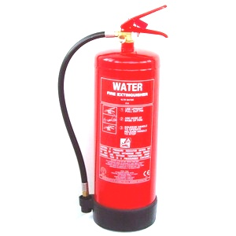
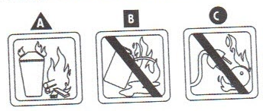

Extinguishing action: (cooling the burning materials especially class A and E fires)

Water is expelled in a limited quantity- maximum of nine litres- under pressure in the form of a jet that has a reach of six to nine metres.

The discharge time is thirty to sixty seconds.
Gas is used to propel the water by chemical action. A gauge located on the side of the valve assembly at the top of the cylinder shows when the extinguisher is properly pressurized. When the operating valve is activated, the water is forced up a siphon tube and out through the hose. Various nozzles are available.
Aim the jet of water at the base of the fire and spray with a sweeping movement. Dampen the surrounding area to stop the fire spreading.
Advantages:

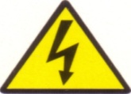
Water is the most effective means of extinguishing of a general nature, although water extinguishers are still in use in some places; it is replaced by fire hose reels.

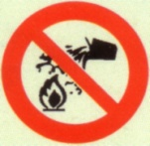
Disadvantages:
Water causes damage although this can be minimized with correct usage. Because water conducts electricity, it cannot be used on fires where live electrical equipment can short circuit and endanger the life of the operator. The electrical current must be turned off at the main before water can be used. Water cannot be used to put out burning flammable liquids as these are lighter than water and will rise to the surface and continue burning. (Most vapours rising from flammable liquids cannot be cooled sufficiently to stop the burning process because the have flash-points at very low temperature)

The foam Fire Extinguisher (Yellow or Cream labels)
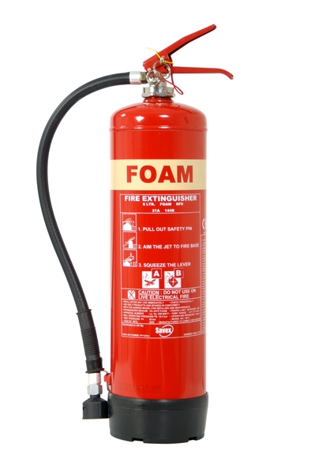
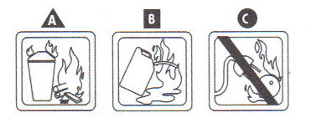

Extinguishing action: (cooling and smothering the fire especially class A and B fires)

AFFF or “Aqueous film forming- foam” is produced by forcing a solution of foam concentrate and water under pressure through an air-aspirating branch pipe. This aerates the solution converting it into foam. The foam blankets the surface of the burning material or substance separating it from the air (oxygen). AFFF cylinders are most commonly ten litres in capacity and their discharge reaches six to eight metres. The discharge time is fifty seconds.

Method of use: Foam must be applied gently to control a fire. When using a foam extinguisher, direct the foam against a sidewall or the vertical surface of the container so that foam runs down and forms a blanket which will spread over the liquid. Where the liquid is not confined, allow the foam to fall gently on it in such a way as to build up a blanket that will flow over the burning surface and so ensure the minimum of disturbance. Changing one’s distance from the fire help with this.
Advantages:
Foam is light and will float above a flammable liquid fire, blanketing it very effectively.
Disadvantages:
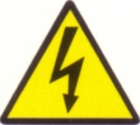
Like water and for the same reasons, foam cannot be used on electrical equipment unless current has been disconnected at the mains. It is ineffective on polar solvents such as acetone alcohol that are water solution. It is also ineffective on fires other than flat horizontal fires.

THE FOAM CAN ALSO BREAK UP IN THE CASE OF MOVING FLAMMABLE LIQUIDS, THUS MAKING IT LESS EFFECTIVE:

The Halon Bromochlorodifluoromethane Extinguishers (BCF) or Halon 1211 (Green labels)

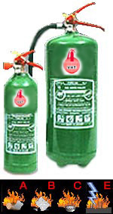

- Halon knocks down flames by chemical inhibiting combustion.
- Halon (BCF) is considered to be harmful to the ozone layer, although Halon extinguishers are still in use in some places, it won’t be replaced after use.

- Halon is suitable for Class B and C fires and small surface burning Class A fires, it can also be used safely on live electrical equipment.

“Beware”

- Re- ignition can occur, so take extra care and reapply if the fire re- ignites. Harmful fumes can be generated if Halon (BCF) is used on hot metals in confined spaces

- After extinguishing the fire, leave the room closing the doors and not re-enter until it is safe to do so, ventilate before re-entry, but take care that the fire does not re-ignite.
BEWARE:
HARMFUL FUMES CAN BE GENERATED IF HALON (BCF) IS USED IN CONFINED SPACES

Class D Fire Extinguishers (colour of label: varies)
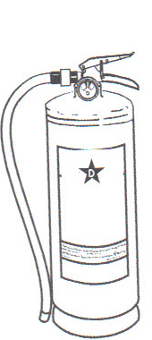

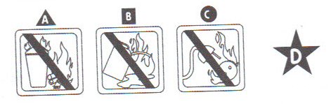

Extinguishing action: (chemical inhibits combustion. It has a blanket effect on D fires)

How it works: Special extinguishing agents in powder form have been developed to control and extinguish metal fires. No single agents will control or extinguish fires in all combustible metals. Some are effective on fire in only one type of metal; others may be effective on more than one type of metal. Some can be applied with portable fire extinguishers other must be applied with shovel.

Method of use: The appropriate application technique for any given powder is described in the manufacturer’s technical literature.
Usually in the form of a dry powder, it must be applied in sufficient depth to completely blanket the fire. The agent should be applied gently to avoid breaking any crust that may form over the burning metal as this would cause the fire to flare up again. Care should be taken to avoid scattering the burning metal.
Never use water on any type of metal fire as this will cause an explosion of the metal, causing an explosion with devastating results. This applies particularly to car engine fires that have taken hold as some car engines are manufactured with alloy that react explosively when combined with water under extreme temperatures.

Advantages:
Effective in containing metal fires other extinguishing agent is unable to extinguish.
Disadvantages:
Cannot be used on class A, B or C fires.
Has to be specific to the metal that is on fire.

Outdoor fires

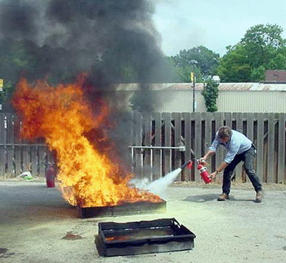

When operating a fire extinguisher out doors, stand windward of fire and as close as possible.
This will ensure that the wind does not carry away valuable extinguishing agent and will avoid it being blown into your face. It will also prevent smoke and poisonous fumes from blowing towards you.
Watch out for changes in wind direction all the time through. To test wind direction give a quick burst of the agent and observe which way it blows.

Vehicle fires

Vehicle fires are nearly always out of doors and wind direction plays a vital role when dealing with these fires.
It is best to keep the bonnet down when a car engine is on fire. This helps to keep the wind and air from fanning the fire.
Undo the catch and lift the bonnet slightly using a cloth to protect your hands from the heat if necessary. Spray the extinguishing agent into the engine compartment through the narrow gap.
With many trucks the engine is under the seat and the extinguishing agent can be sprayed via the gap in the wheel arch. Never tackle a fire that has taken hold of a truck carrying dangerous cargo.
If the dashboard is on fire quick action is required as plastics in a vehicle burn rapidly.
Spray under the dashboard with the extinguishing agent if access is possible.

If the fire involves electrical wires and the fire has not yet taken hold then, if you are able, disconnect the battery before extinguishing the fire.

The Fire Blanket
Available in light (home use) and Heavy Duty (industrial). It combats the fire by excluding oxygen, thus smothering the fire. Place the blanket carefully over the fire.
Always apply it away from yourself, thus shielding yourself from the fire. It is very effective when clothes are on fire and can also be used for fat fires in e.g. the kitchen.

Understand checks, maintenance and service of fire
Equipment:

No equipment can be depended on unless it is well maintained and always ready for use.
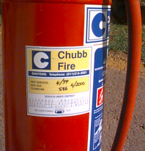
When we need to use the equipment we must know it will function as specified and we need to have confidence in the equipment. Companies usually have a schedule that has been determined by the health and safety officials as to when and how often all fire fighting equipment must be checked and re-certified safe and ready for use in an emergency. If you look on the portable fire extinguishers you should see when last it was inspected and when it is due for re-inspection.

Components of Dry Chemical Fire Extinguisher

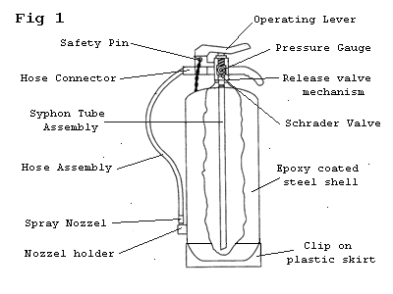

It is important that we understand the following:

- Fire equipment should be entered on a register.
- Visual checks should be carried out monthly and recorded.
- All deviations must be reported.
- Any maintenance, repair or servicing requirements must be carried out immediately
- There must be enough equipment to adequate cover the area while equipment is being serviced or repaired.

- Fire marshals or health and safety representations also carry out visual checks as part of their daily duties and ensure that all equipment is unobstructed
- Servicing must be done by trained and qualified person on at least an annual basis.

Dry powder Fire Extinguisher Inspection:

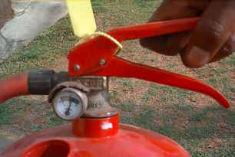
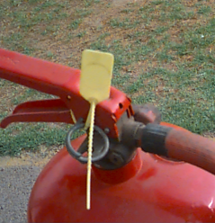

- The location fire extinguishers must be clearly marked and free from obstruction.
- Check that the seal is intact.
- Check that the service hose is not damaged or cracked.

- Check that the nozzle and trigger are not stuck or obstructed.
- Check that the extinguisher is not rusted.
- Check that the pressure gage is indicating a pressure and not zero.

EXERCISE

Practice the inspection of fire equipment

Module Formative Assessment:

(May be used for the Portfolio of Evidence)

The following exercise can be done once a specific section has been
completed.

Please answer the following questions:

1. Identify five (5) different types of fire extinguisher. (5)

2. Explain on which types of fire you can use each fire extinguisher. (5)

3. What does the following letter stand for? (4)

P
A
S
S

4. What needs to be considered when you are attacking a fire outside? (1)

5. When the fire equipment must be inspected and serviced? (1)

MODULE FIVE (5)

Demonstrate the use of fixed hose reels and ancillary extinguishing equipment.

LEARNING OUTCOMES:

At the end of this module the learner will be able to:

- Explain and demonstrate the use of fixed hose reel.
- Explain and demonstrate the use of fire hydrant.
- Explain different types of fire hydrants and hydrant equipment
- Demonstrate the use and the maintenance of fire hose.

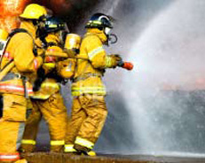

Introduction
Hose reels are first- aid fire- extinguishing equipment suitable for the general protection of a building/company/warehouse. They are provided, primarily, for the use of the occupants and they may be installed instead of or in additional to water- type extinguishers.
Hose reel are simple to use and can be operated by one person.
Each hose reel can provide a substantial volume of water, equivalent to using several extinguishers at once with continuous replenishment. It can be very effective in extinguishing fires in the early stages.
A hose reel consists of a length of non- kinking small-bore rubber tubing, with a shut- off nozzle attached, wound on a metal reel.
The reel is usually supported by a wall bracket and may be arranged to swing on a pivot (A). The reel has a hollow rotating shaft (B), to the centre of which water is fed through a stuffing- box gland (C), the hose tubing (D) being connected to an outlet on this rotating shaft.
The shaft is permanently connected to the water supply through special pipe work.
When considering the installation of hose reel it is advisable to consult municipality fire risk co-ordinator, the fire authority and, if connections are to be made to public mains, the water under- taking concerned.
Components of fire hose reel”
The hose should be made of reinforced rubber and should be no longer than 120 feet (36.6m).
Common lengths of hose used are 60 feet (18.3m), 75 feet (22.9m) 100 feet (30.5m) and 120 feet (36.6m).
Generally the shorter hoses are more convenient to use where there are numerous obstacles.
The standard nozzle bores should be in (4.8mm) 0r in (6.4mm)
Fixed cover is sometimes provided to protect reels against dust and dirt, and to shield them from light, which has a deteriorating effect on the rubber tubing.
Hose reel valve/ taps

Positioning:
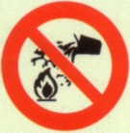
Hose reels should be positioned, preferable near exits or near staircase landings, so that no part of the building is more than 20 feet (6m) from a nozzle when the hoses are fully extended. Allowance should be made for obstructions such as machine, storage and partitions. They should not be installed where the reels or the pipe work may be exposed to freezing temperatures.
Operating Water Hoses
Water hoses are used for cooling a fire and are extremely effective on Class A fires.
Water hoses enable us to spray water onto the fire and thereby cooling it and removing that important element required by fires, namely heat.
Some reasons why water is so widely used to fight fires are…
- Water is affordable
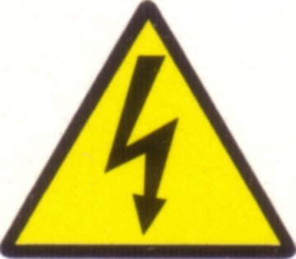
- Water is usually available
- Water is compatible with most other agents
- Water can be transported in large volumes
- Water may be used in many different ways
- Water is obtainable from surface and ground supplies.
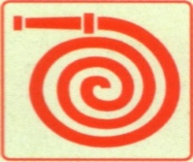
Water hoses that are stored on a reel are usually marked by the following sign and symbol.
When the fire alarm is raised, we need to identify the source and type of fire and then identify the correct fire fighting method and equipment to use.
If we decide that the water hose is the correct equipment, then we need to identify the nearest water hose reel.
- Immediately un-reel” the hose from the storing reel and pull the hose to the desired location.
- We need to be aware of where the hose is going to lie once it has been removed from the reel.
- Remember that the fire hose is manufactured from rubber and may melt if it comes into direct contact with the fire.
- The water hose has a nozzle and a on / off tap.
- When in the open, attack the fire from the windward side and open the nozzle (jet of fog), move forward and ensure that the water can reach the fire.
- Always try to have another employee with an extinguisher backing up as a safety precaution and, where necessary, a two- pronged attack should be made. Make sure that fire has been completely extinguished.

BEWARE:
WATER IS EXTREMELY DANGEROUS WHEN USED ON LIVE ELECTRICAL EQUIPMENT OR BURNING LIQUIDS

Inspection of Fire Hose Reels

Fire hose reel must not be used for other purposes except extinguishing a fire.

- Inspect the nozzle to make sure that it is not blocked.
- Examine and operate the nozzle stopcock, the swinging arm (where appropriate) and the hose guide to ensure that they operate freely. The parts should be lubricated in accordance with the manufacturer’s instructions.
- Close the nozzle stop cock and fully unwind the hose. Make a thorough examination for signs of perishing, mechanical damage and mildew attack.

- Carry out an hydraulic pressure test while the hose is unwound. When the hose is pressurised up to the nozzle, thoroughly examine for leaks, paying particular attention to the connections between the hose and the tubular shaft forming the axle of the reel and between the hose and the nozzle.

- Finally, after inspecting and testing stow hose reel correctly ready for action. If it is not possible to keep hose reels completely clean during inspection, wipe them clean with a rag while being rewound.
This rewinding should be done evenly on the reel to avoid hose falling off behind the reel and thus affecting the ease with which it can be run out during an emergency. The inspection and testing procedure should preferably be carried out by competent fire protection engineering. Any defects discovered should be attended to by the installing engineers/ service provider as soon as possible.

BEWARE:
WATER ALSO BECOME UNSTABLE IN THE PRESENCE OF HIGH TEMPERATURES AND FEED THE FIRE:

Fire Hydrant

A fire hydrant is another water source to which we can attach a water hose and use it to fight the fire.
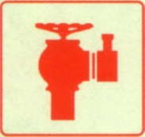
The symbol indicating the location of a fire hydrant is

Fire hydrants are usually installed in areas where a large fire is expected
Fire hydrants enable a larger volume of water discharge and we can therefore attack a larger fire with this equipment.
Types of hydrants
Pillar post hydrant (wet)
These hydrants will usually only be found on an industrial or commercial premises.
The hydrant simulates the combination of a ground hydrant and standpipe and it usually stands approximately 1 metre high, having a wheel control valve and a 65mm female instantaneous coupling with pressure release lug.
On this type of hydrant the hose is connected directly to the hydrant and from there, run out to the fire or pump.

To open the hydrant, the wheel valve is turned in an anticlockwise direction. Should the wheel be missing a spare wheel is carried on the machine for this purpose.
This is the best type of hydrant because it is quick and easy to use and is hydraulically efficient. It is, however, susceptible to damage in uncontrolled areas, loss of wheel valve and washer being common.

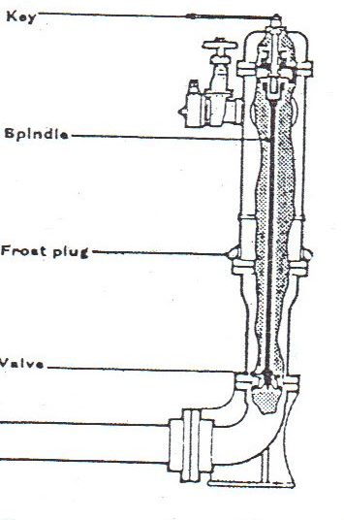
Rising main hydrant (dry)
These hydrants are found inside buildings that are higher than three storeys.(wet risers essential where floor level exceeds 200 feet 61 m)
They will be found in the same location on every floor- normally on the stair landing and approximately 1 metre above floor level.
They are constructed of gunmetal, with screw or flange attachment for fixing to a 100mm feed pipe, and have a 65mm female outlet.
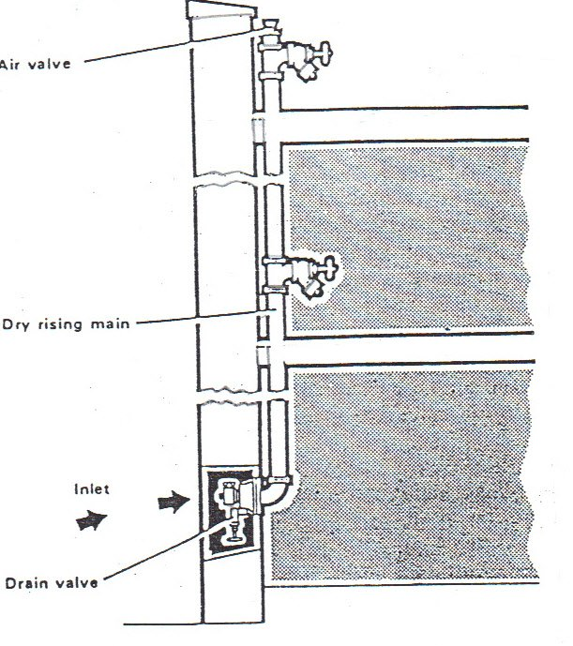

The pipe is called a rising main and travels all the way through the building from the lowest floor to the highest.
The canvas hose can be connected directly to the instantaneous female coupling and run out to the fire, on the floor where the water is required.
Pit hydrant
Street hydrants are usually pit hydrants; they are positioned just below the ground level and are used only by fire brigade.
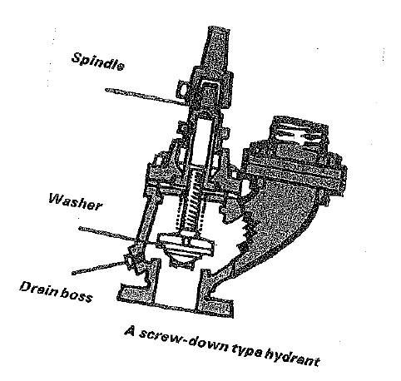 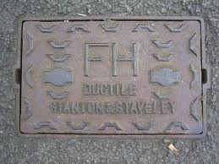 pit hyhdrat cover
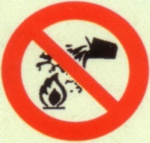
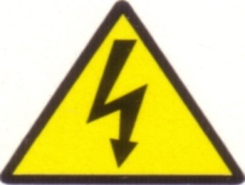
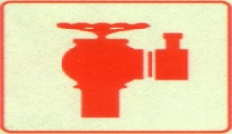

Delivery hoses

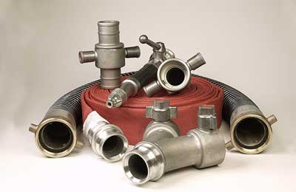
Delivery hoses are used to supply water from a hydrant or pump to the fire scene, which might be over a considerable distance.
Hydrants and pumps supply water under pressure.
A delivery hose has of a number of parts:
- Hose
- Couplings (male and female)
- Branch
Fire team members should be familiar with each of these items and the specific types used in their particular workplace.
Hose
Fire hose comes in length of between 25 and 30 metres. It is classified by the material from which it is constructed and by its internal diameter- 40mm or 65mm. All fire hose has a smooth liner made of rubber or thermoplastic or a combination of the two.
The external construction can be braided, wrapped, woven or rubber- covered and depending on its intended use, it is manufactured as a single or double-jacket, a rubber single jacket or a hard- rubber non-collapsible type. A good quality hose will be:
- Flexible- can be rolled-up smoothly wet or try.
- Durable- can withstand abrasion and rough handling.
- Resistant rot.
- Lightweight enough for ease of handling, without sacrificing
durability.
- Strong- can withstand high internal pressure without losing shape or
bursting.
- Smoothly lined- to reduce friction of flowing water.
Regular inspection and testing of delivery hoses is very important especially after a fire. Delivery hose should be checked for dirt, damage and possible contamination from chemicals after a fire. It should also be checked regularly for mildew, which is caused by storing while still damp or in damp conditions. Hose should be properly cleaned and dried, away from direct sunlight, before stowing.
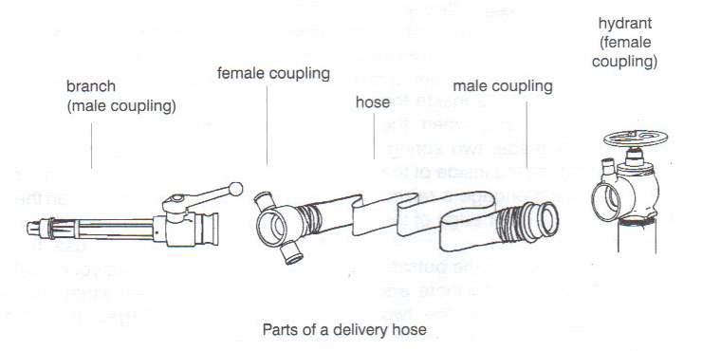Couplings
Hose couplings are alloy fitting permanently attached to the ends of a hose. They are used to connect two hoses together or to connect a hose to devices such as branches, appliances, discharge valves or hydrants.
There are different types of couplings but the most common types of coupling used here is the snap or instantaneous coupling. Like most couplings these have both a male and female component.
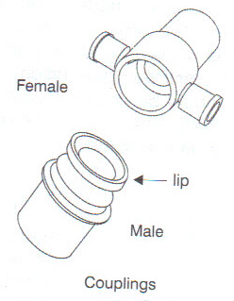
The male coupling fits inside the female coupling and when the connection is made, two spring- loaded hooks on the inside of the female coupling engage a raised ring or lip at the outer edge of the male coupling.
On opposite sides on the outside of the female coupling there are two lugs connected to the two spring-loaded hooks on the inside. When pulled outwards, these lugs disengage the hooks from lip on the male coupling.
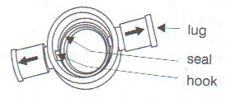
Because two hands are needed to pull the lugs outwards the male side of the hose must be held firmly between the knees while disengaging the couplings
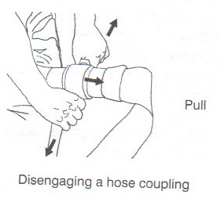
The female coupling has a rubber gasket on the inside that must be inspected regularly for wear and tear. The advantage of instantaneous couplings is the speed with which they can be attached.
One disadvantage is that the lugs in the outside of the female connector tend to catch on obstacles when the hose is pulled along the ground. Not all fire departments use the same couplings. Consult your local fire department to check if they have the same couplings. If not, appropriate adaptors must be acquired in case a fire emergency should arise.
Branches
These are used at the delivery end of a hose to increase the velocity of the water as it reaches the nozzle. Branches may be divided into three principle classes:
- Branches that yield a fine stream in the form of a jet, and cannot be
controlled by the branch operator.
- Those that provide for some form of control by shutting off the jet,
altering its shape or size or changing its character.
- Those that are used exclusively on high pressure reel hoses.

Standard Branches- without control facilities
These are standard in every respect except length. They are normally made of alloys of brass and aluminium
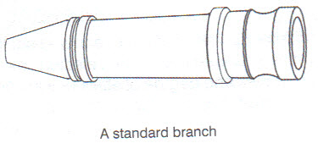
Branch with control facilities
There are a variety of hand- controlled branches available.
With most of them the operator can change the pattern of water stream from jet to a diffused spray or vice- versa, or stop the flow altogether.
One type of hand- controlled branch is known as an A.W.G Branch.
This has a male coupling at one end and at the other end at the other end just before the nozzle; it has a revolving collar which when rotated gives a protective curtain spray. A level control shuts down the jet or opens to spray when moved to the left or right. The A.W.G branch is made of a light alloy.
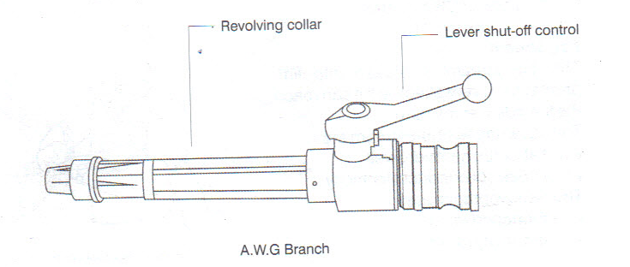
Hand- controlled gun
This branch is pistol shaped. It is made of aluminium, alloy, corrosive resistant steel and nylon. The trigger provides the on/off control and the jet/fog spray control is located beneath the barrel.
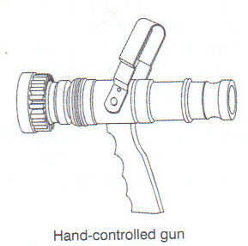
Running out one delivery hose
As all fire hydrants have female couplings the male coupling should always be on the outside of the rolled up hose. Two people minimum are required to run out a delivery hose line that is charged.
Hydrant man
Attach the hose to the hydrant:
- Foot- stand on the end of the hose while it is being run out by
fireman: 1
- Flush- the hydrant to remove any debris that may have built up inside.
- Open fully to do this.
- Feel- to ensure the seal is in place and in good condition.
- Fit- the coupling
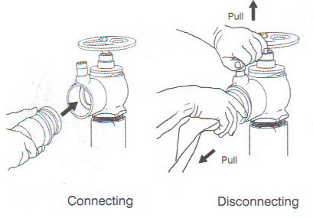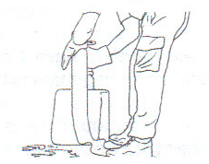

Fireman 1: Tuck the unattached branch under one arm in order to carry it while running out the hose.
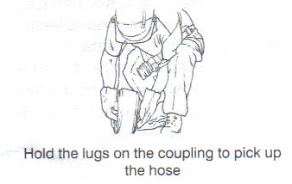
Facing away from the hydrant pick up the hose by holding the lugs on the female coupling with both hands.
Lift it to shoulder height and run forward as it is run out the hose
will rotate.
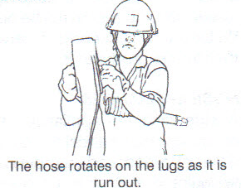

Once the hose is fully run out, attach the branch to it. This is best done in a kneeling position as illustrated.
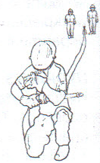

Fireman 2: Take up position behind fireman 1
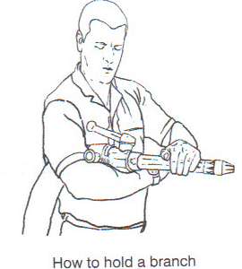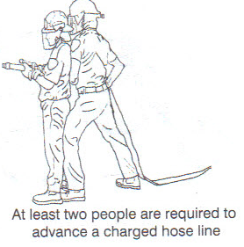

Running out two or more delivery hose
Hydrant man: Attach the hose to the hydrant as describes on the previous page- foot, feel, fit, flush.Fireman 2: Run out the first hose as described on the previous page. Kneel down and hold the coupling in your right hand.
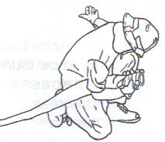
Fireman 1: Tuck the branch under one arm and pick up the second hose. Allow sufficient hose to roll out so that the coupling almost touches the ground. Fireman 2: Stretch out your left arm to receive the male coupling of the second hose from fireman 1 as he passes by.
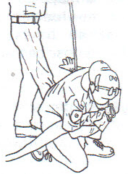

Fireman 1: Move past the outstretched arm of fire man 2, ensuring that the suspended hose line passes over the top of the arm, between the elbow and the armpit.
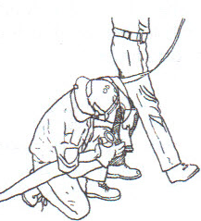
Fireman 2: Take hold of the line and attach the coupling to the first hose. Place the hose on the ground and take your place behind fireman 1 at the branch end of the second hose.
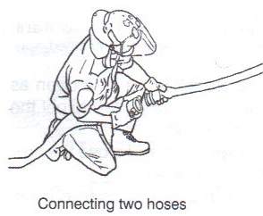

Fireman 1: Run out the second hose as described on the previous page and attach the branch.
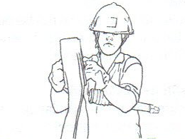
If more hoses are required, repeat these steps, with fireman 4 running out the first hose and fire man 3 running out second hose. Fireman 2 follows and firemen 1 take up the fourth hose and the branch.
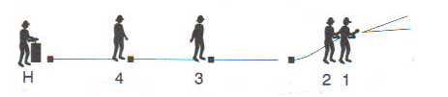
Advancing hose lines
Two things are important here:
- Handling hose line safely
- Communicating effectively
Handling hose line safety
Safety of the team members is of primary importance.
- Wear appropriate fire fighting gear.
- Continually assess the fire to anticipate its behaviour and most likely
direction of spread.
- Switch the branch to full fog pattern when conditions call for retreat,
and back out to a safe area.
- Know where the hazards materials are likely to be found and take all
necessary precautions in these areas.
- Do not direct the stream at personnel or into and are where personnel
may be.
- Clear communication is required at all times so everyone on the hose
can work together.

Branch safety Precautions:
- Nozzles should always be handled and maintained carefully.
- Before the line is charged, the operator should open and close the
branch to ensure that the shut- off works freely.
- The branch should be open as the line is charged to expel the air in
the hose.
- Always open and close the flow control device slowly.
- Once the line is charged, the operator should adjust the discharge
pattern before advancing or operating the line.
- When the operation is completed, operators should set branches to
wide-angle pattern before closing them.
Controlling water flow:
All branches, valves and hydrants should be opened and closed SLOWLY to control
water flow. This prevents sudden changes in branch reaction that can:

- Throw the operator off balance so he loses control of the hose line.
- Cause water hammer that damage everything from couplings to
valves to underground water pipes and should be avoided at all costs.
- If the branch becomes too difficult to handle due to excessive branch
pressure, the operator should change the discharge pattern to full fog
until one of the following takes place:
- Assistance arrives.
- The pressure is reduced or
- The water flow is cut off.
When the operator loses control of the branch the hose team must move in unison to get out of the way of the flailing hose and shut down the pressure.

Communicating
Verbal communication is always possible during a fire emergency, given the loud noises and large distances that may lie between team members while fighting a fire.
A set of standard commands and hand signals should be established and practiced to enable team members to communicate effectively.
Hand sign
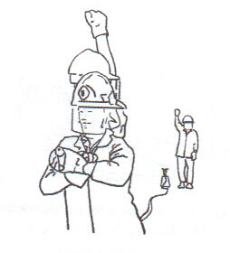
Water on
Hold arm up in vertical position, with fist clenched, to indicate water on
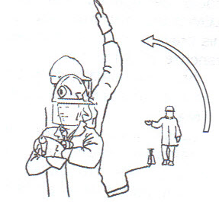
Increase pressure
Raise outstretched arm to vertical position. Repeat several times

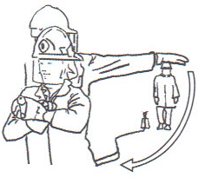

Decrease pressure
Lower outstretched arm to side. Repeat several times

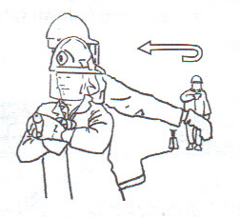
Water off
Bend outstretched arm across chest. Repeat several times

Emptying a hose:
After a hose has been used and before it is rolled, it must be emptied of excess water.
To do this, pick up one end and hold it at shoulder height. Feed the hose through your
hands until the coupling touches the ground. Slow walk forward, holding the hose at shoulder height. Feed the hose back over your shoulder as you move forward. Once
the hose has been emptied it can be rolled.
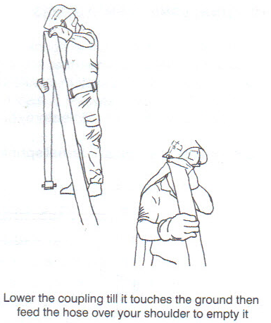
Making up hose
Rolled hose is normally to be preferred with instantaneous snap couplings, as the male coupling can be attached quickly and the female coupling can be used to hold the hose when it is run out.
In this method the hose is laid out flat on the ground and a start is made at the female coupling end. The coupling is doubled down on the hose, which is the rolled up neatly. Do not pull the hose towards you as you roll it, but walk forward to do this, Neaten the roll by patting it down. Rolled hose should always be stowed on its edge and never flat. If it is placed flat the edges are subject to wear and tear.
A roll of hose either wet or dry- should never be dragged along the ground it should always be carried. Wet hoses must be allowed to dry thoroughly before being stowed.
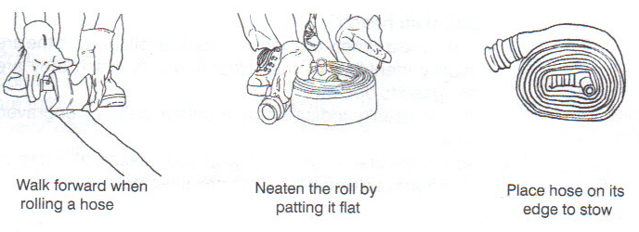

NOTE:
ALL HYDRANTS MUST BE OPENED TO FLUSH OUT DIRT BEFORE CONNECTING HOSE. HYDRANTS MUST BE OPENT AND CLOSE
SLOWLY TO AVOID DAMAGE DUE TO WATER HAMMER

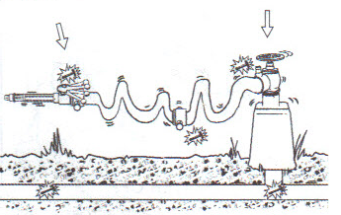
BEWARE
THE WATER PRESSURE FROM THE FIRE HYDRANT WATER HOSE IS
TOO HIGH IN A WAY THAT IT CAN CAUSE INJURIES OR EVEN DEATH

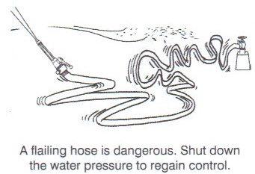

REMEMBER
DAMAGE HOSE IS MADE UP FROM THE MALE COUPLING END SO THAT IT CAN BE SEEN IT IS NOT FOR USE

EXERCISE

Facilitator will demonstrate the replacing a length, figure of 8, figure of “U” and flaking hose methods.

GROUP DISCUSSION

The following exercise can be done once a specific section has been completed.

Please answer the following questions:

1. Identify three (3) components of fire hose reels (3).

1
2
3

2. Why water is so widely use to fight fires? (5).

1
2
3
4
5

3. List three types of fire hydrant (3).

1
2
3

4. Describe three parts of delivery hose (3)

1
2
3
5. List two types of hose couplings (2).
1
2

MODULE THREE (6)

Understanding different types of fire sprinkler systems

LEARNING OUTCOMES

At the end of this module the learner will be able to:

- Understand the function of Automatic Sprinkler System
- Describe types of water supplies
- Identify the different types of sprinkler system
- Know the types of sprinkler heads

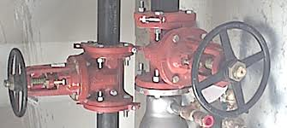

Introduction
Since a most important principle of successful fire extinction is to attach an outbreak immediately, it follows that any device, which can detect a fire automatically and then help to extinguish it with a minimum of fire loss, will prove of great value. Automatic sprinkler systems using water as the extinguishing medium have been universally adopted for this purpose.
Basically an automatic sprinkler installation comprises a system of pipes erected at or near the ceiling of each floor of a building and connected through controlling valves to one or more water supplies.
At intervals in the pipe work, at varying distances according to the classification of the premises, are sealed outlets called sprinklers or sprinkler heads.
These contain a device whereby a rise in temperature to a predetermined limit cases the sprinkler to open and water to be discharged in the form of a spray over an area of the floor below the sprinkler.
The sprinklers are so spaced that, in the event of two or more heads operating simultaneously, the area sprayed by each sprinkler overlaps that sprayed by its neighbor, this leaving no part of the floor unprotected.
The operation of the head leads to the opening of a valve and causes an alarm bell to ring (and in some installations a direct call to the fire brigade), so drawing attention to the outbreak.
Water Supplies
Automatic sprinkler systems must be provided with a suitable and acceptable water supply. The fire officers, committee rules lay down the following as being accepted sources of water supply
- Town mains.
- Elevated private reservoirs
- Gravity tanks
- Automatic pump supply
- Pressure tanks.
Compliance with certain requirements is necessary in respect of each of these sources of supply. The town main is the most common and when forming one of two or more supplies to a sprinkler system, is usually the primary or principle one.
General Requirements
The water supply must have a pressure and flow characteristic not less than that specified in the Fire offices’ committee rules. It must be automatic, thoroughly reliable and not subject to either frost or drought conditions that could seriously affect the supply.
The supply should be under the control of the occupier of the building containing the installation or, where this is not practicable, the right use of the supply must be suitably guaranteed.
The water must be free from any matter in suspension which would be liable to cause accumulation in the system pipe work. The use of salt or brackish water is not normally allowed.
In special circumstances where there is no suitable fresh water source available, consideration may be given to the use of salt or brackish water provided that the installation is normally charged with fresh water.
Types of Sprinkler Systems
There are six types of standard sprinkler systems. They are:
- Wet pipe
- Dry pipe
- Alternate wet and dry pipe
- Pre-action
Wet Pipe System
In this system, the commonest and simplest in general use all the pipes that lead from the water supplies through the various controlling valves to the sprinkler heads throughout the building are kept permanently filled with water.
Wet pipe systems are installed in premises where there is no danger at any time of the water in the pipes freezing.
The principal controls of such a system are:
- a stop valve on each separate source of supply,
- a non-return valve on each source of supply
- an installation main stop valve to cut off the flow of water to the system after a head has opened and the fire has been extinguished,

- an alarm valve, which lifts when water enters the sprinkler feed pipes and permits the passage of water to the alarm gong, this valve also acts as a non return valve to prevent the return flow of water from the sprinkler pipes to the supply connections,
- a test and drain valve, used for providing the water supply to the installation and to empty the system when necessary.
There are three gauges, namely:
- Gauge which show the pressure in the installation itself above the main stop and alarm valves.
- Gauge which show the pressure of the supply below the main stop valve.
- Gauge which shows the pressure in the towns main.

Wet pipe systems are so designed that the number of sprinklers controlled by one set of valves (including tail end extensions) does not exceed 500 in extra light hazard systems or 1000 in ordinary and extra high hazard systems.

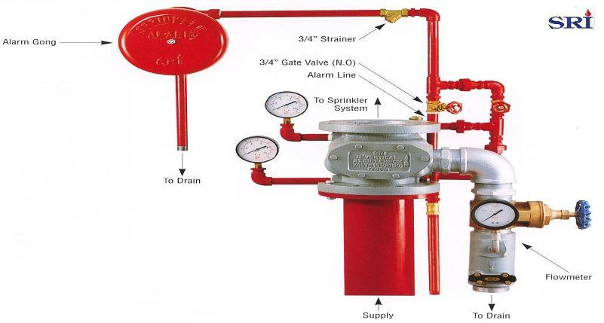
Where more heads than this is installed, two or more sets of installation valves should be employed.
Each set of valves must have a number in bold figures. In wet installations, the sprinkler heads may be installed in either the upright (above the range pies) or pendant position (fitted to the underside of the range pipes).

Dry Pipes System
This type of system is only allowed in buildings where the temperature conditions are artificially maintained close to, or below, freezing point, such as in cold or cool stores and fur vaults, or where temperature is maintained above 70°C, as in drying ovens.
The pipes are at all times kept in charged with air under sufficient pressure to hold back the water. The controlling valves of a dry pipe installation comprise a main stop valve, as in the wet pipe system, and a different air valve, which is a substitute for the alarm in a wet system.
When a sprinkler head opens the compressed air escapes and water enters the system and eventually reaches the open sprinkler head. It will be appreciated however that there is some delay before the water reaches the head on account of the time required to release sufficient compressed air from the system to allow the air valve to open and water to enter and travel up to the pipe to the open sprinkler head.
A device known as an accelerator is therefore normally fitted or a special type of valve is incorporated, the function of which is to speed up the entry of water into the system. It is undesirable to maintain a greater air pressure in the system than is necessary and approximately one quarter of the maximum pressure is the normal figure. Provision is made for replacing the slight leakage, which takes place.
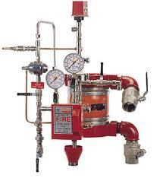
The differential air valve of a dry pipe system
- in the closed position.
- in the open position.
Alternate Wet and Dry System
This system is usually installed in premises without adequate artificial heating where the water in the pipes of a wet system would be liable to freeze during cold weather. It usually operates on the wet principle in the summer and the dry principle in the winter. When functioning on the wet system, the dry valve is either changed over or placed out of commission and the system functions as a wet system.
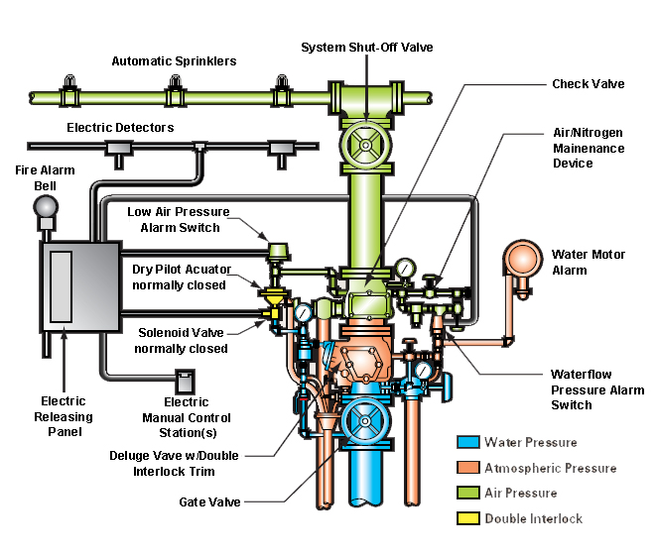Pre-Action System
A pre-action system is a combination of a standard sprinkler system and an independent approved system of heat or smoke detectors installed in the same areas as the sprinklers.
In general, heat or smoke detectors operate prior to the sprinklers and so a “pre-action valve” will open to allow water flow into the sprinkler pipe work before the first sprinkler operates. The sprinkler system pipe work is normally charged with air under pressure and is monitored so that an alarm is given on reduction of air pressure.

Causes which may produce the ringing of the alarm gong
There are four causes which may produce a ringing of the alarm gong:
- The opening of a sprinkler head
- The opening of a drain or test valve
- Damage to any part of the installation which leads to an outflow
- A rise in the pressure of the water being supplied to the installation, thus lifting the alarm and allowing water to pass to the turbine operating the gong

Sprinkler heads group

There are different designs of sprinkler heads but the may be divided into two categories.

- Those in which they operate medium is fusible solder;
- Those in which a bulb is ruptured by the expansion of a container liquid.
- Fusible Solder Type
When the temperature surrounding the head rises to a level at which the solder is heated to its fusing point, the strut, hook and key fly apart owing to the under which they are held. The valve cap is released and allows the water an uninterrupted passage to the deflector.
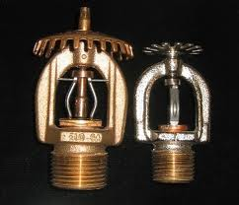
- Bulb Type
As the temperature rises, the liquid expands and the size of the bubble decrease until it disappears. A further rise shatters the bulb, breaking in into small pieces so that it cannot obstruct the water flow, so open the head.
In spite of this ease of fracture, the strength of the bulb is such that it can withstand any pressure applied to the pipe. In a pressure destruction test, it is the metal parts of the head that fails first.

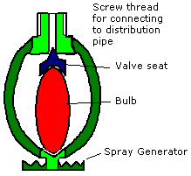

Types of sprinkler heads

Sprinklers must be of approved types and makes. They must not be altered or modified in any way not have any ornamentation or coatings applied after leaving the manufacturer except corrosion – resisting coatings or petroleum jelly.
The following types of sprinklers are acceptable for general use.
- Dry pendent pattern
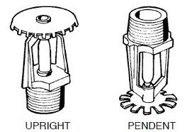

- Ceiling flush pattern
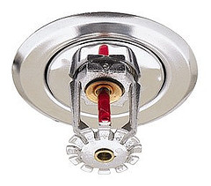
- Sidewall pattern
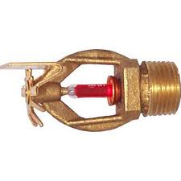
Sitting of Sprinkler Heads
The following definitions are used to differentiate between the various pipe work used on a sprinkler installation.
- Main distribution pipes: Main pipes feeding the distribution pipe work.
- Distribution pipes: Pies directly feeding range pipes.
- Range pipes: Pipes on which the sprinklers are attached either directly through short arm pipes which do not exceed 300 mm in length.

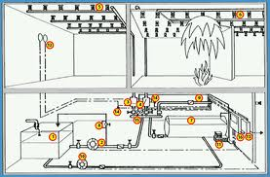
The number of sprinklers allowed on range pipes depends on the layout and size of the pipe used, but does not exceed nine on any one pipe.
The number of sprinklers fed by a distribution pipe is also determined by the size of the pipe, with a maximum of 48 heads fed by one distribution pipe. Pipe sizes are determined by hydraulically calculations.

Fire Fighting procedure in sprinkler system
The following are the principal points a fire fighter should bear in mind when fighting a fire in a sprinklers building.
On arrival at a fire in a sprinkler system, a member of that team should immediately be sent to the main stop valve so that:
- He can open the valve if he finds it closed, and he can ensure that the valve is not closed except on the express instructions of the officer in charge.
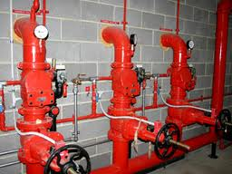
- It should be remembered that there are many cases where sprinklers will satisfactorily hold the fire which can then be finally extinguished by firemen using hose reels. The sprinklers should not normally be turned off in order that the fire may be fought with jets or spray branches unless the fire officers are fully convinced that further operation will simply waste water and produce heavy water damage.
- If additional water is needed, it should not be taken from the main supplying the sprinklers unless it is of large size.
- Although a sprinkler may appear to have extinguished the fire, careful examination of the area involved must be made in order to verify that no trace of fire remains under tables, pipes or stacks of good.
- When a fire is out if for any reason it is impossible to turn off the main stop valves immediately and cut off the flow of water to the sprinkler head, water damage can be prevented by securing the female coupling of a length of hose over the head and directing the hose out of a window.
- Automatic Systems not using water:
Where a carbon dioxide system has activated, it should be remembered that while carbon dioxide is not toxic it is asphyxiating and men cannot enter without BA’s. Venting should not be commenced until a thorough search has been made of the affected area by BA teams to verify that the fire has in fact been extinguished.
Carbon dioxide
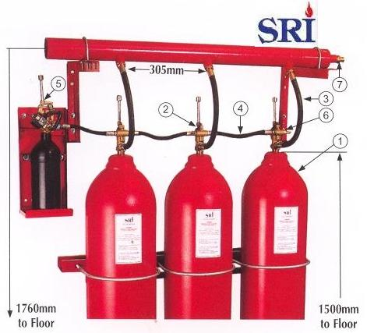

Gas extinguishing systems work in one of two ways. By reducing the oxygen content either of the atmosphere or by interrupting the chemical reaction in a flame. The gas is delivered through pipes and the systems involve automatically closing doors and ventilation ducts.

NOTES:
------------------------------------------------------------------------------------------------------------------------------------------------------------------------------------------------------------------------------------------------------------------------------------------------------------------------------------------------------------------------------------------------------------------------------------------------------------------------------------------------------------------------------------------------------------------------------------------------------------------------------------------------------------------------------------------------------------------------------------------------

GROUP DISCUSSION

The following exercise can be done once a specific section has been completed.
Please answer the following questions:

1. Identify three types of sprinkler water supplies (3).

1
2
3

2. List four types of sprinkler system (4).

1
2
3
4

3. Describe the causes which may produce the ringing of fire alarm (3).

1
2
3

4. Name one automatic sprinkler system which is not using water (1).
1

5. What is the disadvantage of carbon dioxide sprinkler system? (1)

1

MODULE SIX (7)

Fire policy and procedures in the workplace

LEARNING OUTCOMES:

At the end of this module the learner will be able to:

- Explain what to do when discovering a fire.
- Describe general fire evacuation procedure.
- Know how to move in smoke
- Know how to retreat and hand over

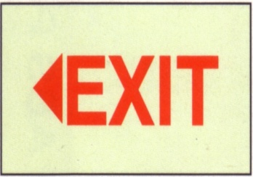

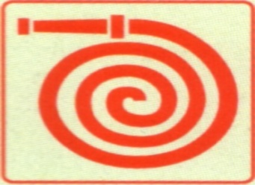

Introduction

When fire gets out of hand it is a traumatic experience for the persons involved. A fire involving many people, multiplies the trauma. So what do you do when you discover a fire? The safety and lives of many people may depend on the way you react, your reaction during the first stage of any fire is critical to the outcome of event, and some people work in high-rise building and others in factories or small offices. All situations are different. If you know the basic procedures it is easier
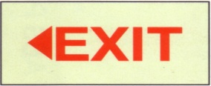
to adapt them to suit your personal work situation

Procedure in the event of Fire

The action which is appropriate on discovering a fire will depend on how far the fire has been developed and how quickly it is likely to spread.
Many fires are discovered in the early stages and can be brought under control by prompt action.

Clearly precise fire instructions should be drawn up detailing the action that all employees should take in the event of a fire occurring.
They should cover the essential steps of:

- Raising the alarm
- Calling the fire brigade
- Tackling the fire
- Evacuating the premises.

What to do when you discovering a fire

When you discover fire stay calm, do not panic, Panicking will affect your ability to act effectively and may frighten other unnecessarily.
Nearly all fires develop slowly at first and should be attacked immediately on discovery with the first- aid fire- fighting equipment available, providing there is no personal danger in doing this.

Circumstances must dictate whether attack should take priority over reporting, clearly it is undesirable to allow a small fire to obtain a hold through spending time on reporting, but on the other hand, it is dangerous to delay reporting any outbreak which may not be contained by immediate personal effort.
In most instances, however, there will be other people near at hand. Where this is so, the person discovering the fire should immediately try to contain it, at the same time instructing another person to report the outbreak.

Having reported and sounding the fire alarm, the second person should, without taking unnecessary risk, collect another appliance and assist in extinguishing the fire.
If the fire continues to grow, leave the building and report to the assembly point.
Remember, certain fires should be left to the experts or trained personnel.

What to do on Hearing the Fire Alarm

Employees
The first thing to ensure is that all employees know what the fire alarm sounds like, they must also know:
- The particular things they have to do before leaving their job, such as shutting down their machine or closing a fire door.
- The normal and emergency escape routes from their position in the building.
- The pre- arranged assembly point and the person to whom they have to report there.
Fire Team
Once the fire alarm has been raised, all trained fire fighters should respond.
We first need to establish…
- How big is the fire?
- What is the source of the fire?
- What type or class of fire are we dealing with?
- Do we have the correct fire fighting equipment?
- Ensure someone is in charge of the evacuation of people not involved in the fire fighting efforts.
BEFORE COMMITTING TO FIGHT THE FIRE
ASSESS THE RISK TO YOURSELF AND THE OTHER FIRE FIGHTER

Notify the Fire Department in the event of a fire incident, regardless of its size. Usually the fire warden should call the Fire Brigade but all employees should know how to do so (see page 10)

Guidelines for combating a fire
“BEWARE”

DO NOT let a fire get between you and your escape route. Make sure you can escape if you need to.
DO NOT use you extinguisher if you have any doubt whether is suitable for the fire or not. Make sure that you have the right equipment and enough backups.
DO NOT open a door without feeling it first with the back of your hand. If you feel heat, there is probably an advanced fire behind it. If its relatively cool the fire might be in its early stages.
DO NOT tackles a fire if it is starting to spread to other items in the building. If it seems to get out of hand, evacuate the building immediately.
DO NOT ventilates a room before you are sure the fire is out. It could flare up again and spread very rapidly.
DO NOT fight a fire when the room is filling with smoke. Remember smoke
can kill more easily than the fire itself.

REMEMBER
IF THE FIRE IS OUT OF CONTROL WITHDRAWN IMMEDIATELY

DO’S
- Only tackle a fire in its very early stages.
- Always put your own and other people’s safety first. Never risk injury to fight fires.
- Always stay behind the doors or the wall for protection if you have to open it. Attempting to open a door could be very dangerous.
- Always go in as low as possible. Heat rises. The higher you are above the fire the hotter it will be.
- Watch out flash-over.
- Always close doors and windows on the way out. This will help to contain the fire. In many cases the fire can burn itself out if it does not get more oxygen.
- Always make sure the fire department has been called
- If you are in doubt, get out immediately.

Ensure that the Emergency Telephone Number is Displayed and
Everyone knows where to look in case of Emergency

Evacuating the building

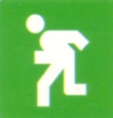
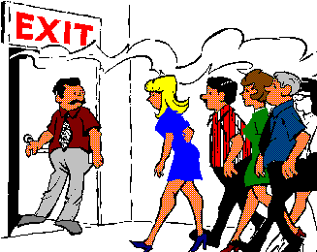

An essential priority in a fire emergency is the evacuation of al the occupants of the building. Dangerous smoke and fumes caused by a fire spread rapidly through a building and they can kill more easily than the fire itself.

Every workplace will have a unique system for evacuating people. Regular fire drill is tedious but necessary, as everyone should know exactly what to do, where to go and how to get there to avoid confusion should a real emergency happen.

In large building, a system of fire marshals in each area or on each floor controlled by a chief fire marshal is usually the most effective.
Appropriate signs, route maps and clear marked exits form part of the procedure.

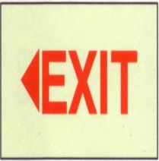
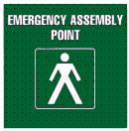
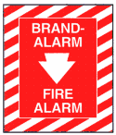
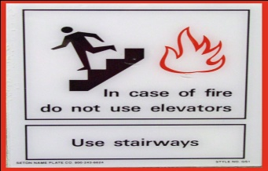

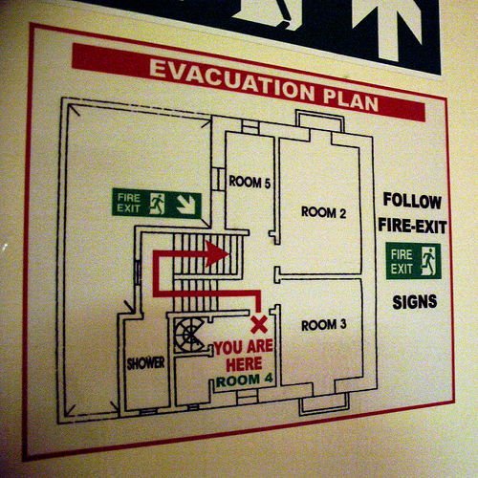

Guidelines for a safety evacuation (Do’s)

- Leave the building by the most direction route available as soon s the alarm sound.

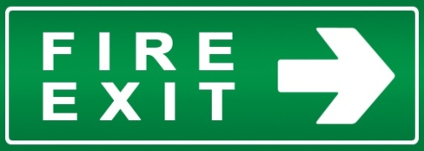

- Do this in an orderly manner
- Remove personal belongings, for example handbags, briefcases.
- Follow the orders of wardens who will be trained in the evacuation procedures.
- Help disable people to leave the building safely.
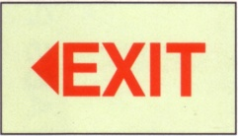
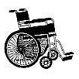
- Identify these people beforehand and accommodate them in your evacuation planning.

- Assist visitors and other people who are unfamiliar with the building.
- Use the fire escape route (If high-rise building, do not
use the lift, you can get trapped in case of power failure, the lift shaft is a dead trap, smoke and fire can also spread through lift shaft).

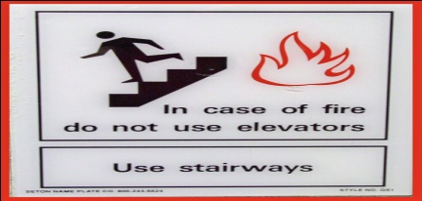

- Close all doors and windows if it is safe to do so when evacuating a office or area in the warehouse or company. This will help to stop the spread of fire, smoke and heat.
- A crouching attitude should be adopted to protect yourself against heat and smoke.
- Keep against the wall and away from the railing where possible.
- Go to your fire assembly point immediately on leaving
the building.

- Report to the person in charge, so that you can be checked off against the register of attendance.
- Tell the person in charge of anyone that might be missing.

High-rise-buildings

In high- rise building, floors above the fire and one floor below the fire should be evacuated. In serious situations all floor above and below the fire should be evacuated.
During total evacuation different floors should not be evacuated simultaneously to avoid congestion.
Evacuation should not be allowed upwards in multi- storey buildings, because fire spread upwards. Rescue from the top, for example by helicopter, might not be possible. However, if not other route is available, move upwards in the hope that the fire will be controlled or a rescue operation can be started.

Beware”

DO NOT use the lifts. You can get trapped in case of a power failure. The lift shaft is a death trap. Smoke and fire can also spread through lift shafts.

DO NOT stops to finish work in hand.

DO NOT return to your work station. This not only endangers your own safety, but those of the people who have to come and rescue you,

DO NOT go back into the building to fetch anyone or any valuables. Leave that to trained and equipped rescue teams.

DO NOT re-enter the building until the fire brigade says that it is safe to do so.

General guidelines for moving in smoke
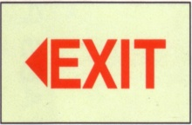
- Move in group of single file
- Hold on the person in front of you with one hand.
- Protect your nose with the other hand or wet cloth.

- Find a wall and move along it.
- Always move in one direction. Do not turn around to move in the opposite direction.
- Shuffle, do not walk. This will help you not to fall over objects laying around
- Move as quickly as possible, but do not run.
- If the smoke is lighter than oxygen, crawl out staying close to the floor
- Always feel with the back of your hand. When receiving an electrical shock, your muscle contracts involuntary. This can cause you to grab onto an open electrical wire and not be able to let go.
- Feeling with the back of your hand eliminates this danger.
- Communicate all times. This helps to reassure and encourage people.

- If you are a team leader do a heard count as often as possible by asking the people to “number”. This way you will know when someone gets lost.
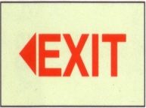
- Remember that smoke is lighter than air and will always rise. This means that fresher air will always be close to the floor. Therefore it is sometimes advisable to crawl underneath the smoke when it gets very dense. However, always be aware that some toxic fumes may be heavier than air and fall to the floor.
- Remain calm as panic breeds panic.
- Look for luminous exit signs. This might be your only safe way out.
- Do not go back for someone who got left behind. Try and remember where the person got lost and tell the rescue team when you reach the assembly point.
Retreating and handing over

Once the professional fire fighting teams arrive at the scene we need to hand over the scene to them and retreat, letting them take over and fight the fire with their professional teams and equipment.
When they arrive, do not just stop fighting the fire, but let your team continue for the time being.
As Fire Marshall of the fire team, introduce yourself to the leader of the professional team and explain…
- What happened?
- What you have done so far.
- Where the fire is at its worst.
- Where your team is.
- Any injury or trapped people.
- Where flammable material or liquids are stored on the premises.
Check with the professional fire fighters team leader whether your team is still required and if so where and what can your team do to assist.
If required, take instruction from the professional team leader and assist as required and directed.
If not required, check whether you may withdraw your team and let them continue.

NOTE:
ALWAYS ENSURE THAT THE FIRE IS COMPLETELY
EXTINGUISHED AS FIRES OFTEN RE-IGNITE

GROUP DISCUSSION

The following exercise can be done once a specific section has been completed.

Please identify the following symbols:

----------------------------------
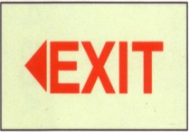
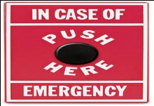 -----------------------------------

----------------------------------
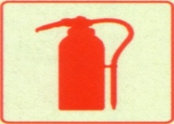
-----------------------------------
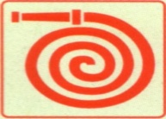
-----------------------------------
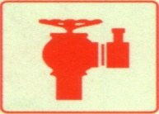
-----------------------------------

ASSESSEMENT

Once all the course content has been successfully covered and your facilitator feels confident that you are ready to attempt the knowledge assessments, you will be prepared for the assessment and proceed with the knowledge assessments.

Once you have practiced all the relevant tasks and your facilitator feels confident that you are ready to attempt the performance assessment, you will be prepared for assessment and proceed with the performance assessments.

REMEMBER----
WITH YOUR TRAINING AND FIRE FIGHTING EQUIPMENT YOU CAN ONLY FIGHT FIRES ON A CERTAIN SIZE OF FIRE AND MAY NEED TO REQUEST ASSISTANCE FROM THE PROFESSIONAL FIRE FIGHTING SERVICE IF THE FIRE IS OUT OF CONTROL.

REMEMBER
AS A PROFESSIONAL FIRE FIGHTER YOU WILL NEED TO IMPLEMENT AND APPLY ALL YOU HAVE LEARNT IN THESE TRAINING SESSIONS…
NOT ONLY WHEN YOU ARE BEING ASSESSED

YOU ARE NOW READY TO GO AND PRACTICE WHAT YOU HAVE BEEN TAUGHT

REMEMBER …
SAFETY IS YOUR PRIMARY
CONCERN AND RESPONSIBILITY

